<pp>1

Western Australian Treasury Corporation

Annual Report 2024
Our purpose is to provide financial solutions for the benefit of the Western Australian public sector.
Image Caption: Decorative only. Photo of Narrows Bridge and Perth city skyline.



Image Caption: Western Australian Treasury Corporation logo
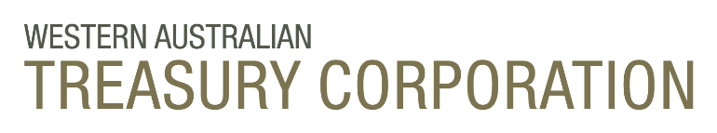

Image Caption: Western Australian Treasury Corporation tagline – Financial Solutions for the Benefit of All Western Australians
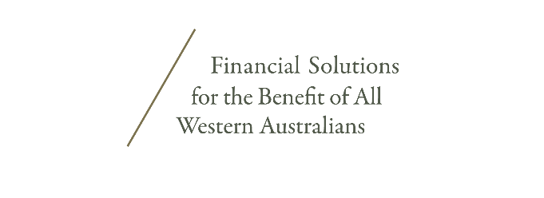
<pp>2

Acknowledgement of Country
We acknowledge the Traditional Custodians throughout Western Australia and their continuing connection to land, waters and community. We pay our respects to all Aboriginal peoples and their cultures, and to elders both past and present.

About this Report
This annual report provides information about the services and performance of Western Australian Treasury Corporation and includes audited financial statements and performance indicators for the financial year ended 30 June 2024. A full copy of this annual report, along with previous years’ annual reports, is available in portable document format (PDF) and other formats on our website at watc.wa.gov.au. Hard copies are printed on paper that contains 100 per cent recycled fibre and is FSC® Mix Certified, which ensures that pulp is derived from well-managed forests and recycled wood or fibre. Manufactured by an ISO 14001 certified mill.
Image Caption: Decorative only. Western Australian Christmas tree (Nuytsia floribunda) and grass tree (Balga), Cape Le Grand National Park. Image courtesy of Tourism Western Australia.



<pp>3

Contents

Overview
Statement of Compliance
Purpose, Objectives and Values
Financial Year Snapshot
Key Achievements
Chairperson and CEO’s Report
Performance Against Targets
About Our Organisation
Board of Directors

Agency Performance
Providing Value to Clients
Successful Financial Management
Optimising Our Performance

Disclosures and Legal Compliance
Managing Our Information Assets
Our People
Board of Directors’ Governance
Board Committees
Legislation
Corporate Governance

Financial Statements
Removed from this version – may be provided in alternative formats on request.

Contact Details
Western Australian Treasury Corporation
Registry Information
Image Caption: Decorative only. The Bell Tower. Image courtesy of Tourism Western Australia.


<pp>4

Overview
In this section:
Statement of Compliance
Purpose, Objectives and Values
Financial Year Snapshot
Key Achievements
Chairperson and CEO’s Report
Performance Against Targets
About Our Organisation
Board of Directors

Image Caption: Decorative only. Lions Lookout, Korung National Park. Image courtesy of Tourism Western Australia.



<pp>5

Statement of Compliance
For the year ended 30 June 2024

To the Honourable Rita Saffioti BBus MLA
Deputy Premier; Treasurer; Minister for Transport; Tourism

In accordance with Section 63 of the Financial Management Act 2006, we hereby submit for your
information and presentation to Parliament, the Annual Report of the Western Australian Treasury
Corporation for the financial year ended 30 June 2024.

The Annual Report has been prepared in accordance with the provisions of the Financial Management Act 2006.
Yours sincerely,

M BARNES PSM, FIPAAWA
CHAIRPERSON
Western Australian Treasury Corporation
23 August 2024

K GULICH PSM
CHIEF EXECUTIVE OFFICER
Western Australian Treasury Corporation
23 August 2024

<pp>6

Purpose, Objectives and Values

Purpose
To provide financial solutions for the benefit of the Western Australian public sector.

Objectives
- Provide high-quality, cost-effective products and services to the Western Australian public sector.
- Maintain access to domestic and international capital markets to ensure funds are raised to finance client borrowing needs in a timely and cost-effective manner.
- Ensure the efficient, sustainable performance of Western Australian Treasury Corporation in accordance with the risk appetite of our Board.

Values
We operate our business in accordance with our values.

Integrity
We are open, honest and accountable. We adhere to the highest professional and ethical standards. We honour our promises.

Partnership
We work collaboratively with our stakeholders and colleagues towards achieving successful outcomes.

Adaptability
We challenge ourselves to think creatively and to continuously improve.

Achievement
We are engaged and focused on delivering valued outcomes for Western Australia.

Leadership
We use our knowledge and experience to contribute to the long-term benefit of Western Australia.
View more information about our organisation on our website:
Who We Are (watc.wa.gov.au)

<pp>7

Financial Year Snapshot
At 30 June 2024
Total Debt
$50.4b
↑$0.6b

We source funds from domestic and international financial markets on behalf of the State of Western Australia. This year our total debt on issue amounts to $50.4 billion. Find out more on page 80.

Client Debt
$45.4b
↑$0.5b

We provide debt funding for government entities, local governments and public universities.
This year our total client debt amounts to $45.4 billion. Find out more on page 25.

Foreign Exchange
$1.8b
↑$1.25b

We transact foreign exchange currencies and manage foreign exchange risk for our public sector clients.
This year we transacted a total of $1.8 billion in eight currencies on behalf of 15 clients. Find out more on page 32.
Advisory Engagements
94
↑$0.5b
We provide debt funding for government entities, local governments and public universities.
This year our total client debt amounts to $45.4 billion. Find out more on page 25.

<pp>8

Key Achievements

Strong Credit Ratings
Western Australia’s Credit Rating Upgraded to Aaa
Moody’s Ratings upgraded Western Australia’s credit rating to Aaa in July, highlighting our
State’s financial strengths. Western Australia is the only Australian state or territory with
a triple-A credit rating from both international rating agencies.
Find out more on page 19

Industry Recognition
Our Green Bond and Chief Executive Officer Receive Awards
Specialised information service KangaNews awarded our 2033 green bond Australian Sustainability Bond Deal of the Year and our CEO, Kaylene Gulich, one of their Market People of the Year.
Find out more on page 39

Exceptional Feedback
Our Clients Continue to Express High Levels of Satisfaction
Feedback from our public sector clients confirm they continue to be extremely satisfied with our overall capabilities, the quality of advice, the value we add to projects and the services we provide.
More on page 26
<pp>9

Transition to Renewables
Supporting the Delivery of Large-Scale Battery Energy Storage Systems
Our Corporate Treasury Services team worked closely with Synergy in the management of its foreign currency exposures to deliver groundbreaking projects that support the storage of renewable energy in Western Australia.
More on page 31

Increased Service Demand
Growing Advisory Engagements Confirm Our Valued Advice
The demand for our Advisory Services increased significantly, resulting in nearly double the number of engagements compared with the previous year, confirming the high level of quality and value for money that our team provides.
More on page 26

ESG Commitments
Sustainability Bond Framework Annual Report Released
This first report consolidates our journey to becoming a committed participant in the sustainable finance market and showcases the State’s progress towards accelerating climate outcomes and achieving its environmental, social and governance (ESG) ambitions.
More on pages 38

<pp>10

Chairperson and CEO’s Report

In what has been another year of unpredictable and challenging global economic and financial conditions, Western Australian Treasury Corporation (WATC) successfully delivered on the State’s borrowing requirements, continued to meet our clients’ evolving financial needs, and achieved all of our key performance metrics.

Throughout the year, the global economy and financial markets demonstrated resilience to elevated interest rates, continuing uncomfortable levels of inflation and ongoing geopolitical tensions. While some further normalisation is anticipated, these challenging conditions are expected to continue into 2024–25. Western Australia’s continued economic resilience means that the State Government and WATC are well positioned to withstand these conditions.

While the risk of a global recession has been averted, thanks in part to the US economy’s resilience to high interest rates and reasonable growth in China’s economy despite continuing property market weakness, global growth remains moderate and continues to face multiple headwinds.

Most major central banks have concluded the steepest tightening cycle in the history of the inflation-targeting era, with some banks already starting to adjust policy rates downwards. However, across the advanced economies interest rates remain at, or close to, decade-long highs. At home, rate cuts by the Reserve Bank of Australia (RBA) are not priced in by the cash rate futures market until the second half of the 2024–25 financial year. While inflation in Australia has eased significantly from 2022 highs, it is still above the RBA’s target range of 2–3 per cent.

Interest rates are expected to remain above pre- COVID levels, even after the anticipated upcoming monetary easing cycle comes to an end. This is due to a range of factors keeping inflation higher than before the pandemic, as well as high public debt levels across the major advanced economies.

<pp>11

Geopolitical tensions continued in 2023–24, with the ongoing war between Russia and Ukraine, and the escalation of conflict in the Middle East in October 2023. As noted, troubles in China’s property sector continued, although Chinese demand for iron ore remained strong throughout 2023–24. However, looking over the longer term, the outlook remains uncertain as China’s economic growth continues to moderate and the composition of growth is gradually changing.

Despite the above challenges, our State’s economic performance remained exceptional in 2023–24, outperforming all other Australian states and territories. Western Australia had the fastest State Final Demand (SFD) growth over the year to March and the lowest unemployment rate of mainland states in June. Coupled with the ongoing demand for Western Australia’s commodities, this helped our State achieve its sixth consecutive general government operating surplus in 2023–24. The outlook for coming years includes continuing solid growth in SFD, further operating surpluses, and a net debt profile that continues to remain the lowest of all states, despite a record Asset Investment Program.
Reflecting the continued strength of the Western Australian economy, in July 2023 Moody’s Ratings revised Western Australia's credit rating to Aaa with a 'stable' outlook, again highlighting our State’s ongoing strength in financial management, sustained budget surpluses and the easing of debt. Western Australia is now the only Australian state or territory with a triple-A credit rating from both major international rating agencies.

Similar to our equivalents worldwide, WATC bond yields remained higher than before COVID-19, with 10-year yields ranging between 4.45 and 5.60 per cent. The State’s sound fiscal position, low net debt profile and top credit ratings translated into the narrowing of spreads between WATC bond yields and Commonwealth bond yields that continue to remain the narrowest of all the States.

Following last year’s release of our Sustainability Bond Framework and the successful launch of our inaugural green bond, in December we published our first annual report under the framework. The report consolidated WATC’s journey to becoming a committed participant in the sustainable finance market. It also showcased Western Australia’s progress towards accelerating climate outcomes through projects within our green bond, while delivering on our commitment to transparent and timely reporting.
Further validating the great work of WATC in supporting our State’s environmental, social and governance transition, our green bond won the KangaNews Awards 2023 for Australian Sustainability Bond Deal of the Year. WATC Chief Executive Officer, Kaylene Gulich, was also honoured to be awarded as one of the KangaNews Market People of the Year.

It was also pleasing to receive a Silver Award for our 2023 annual report as part of the Institute
of Public Administration Australia WA’s 2023 WS Lonnie Awards. These awards recognise and promote excellence, accountability and transparency in annual reporting across the Western Australian government sector.

We continued our program to actively engage with investors through various forums. During October we were pleased to host domestic and international investors in conjunction with the

<pp>12

Commonwealth Bank’s 2023 Global Markets Conference. The two-day Western Australian component of the conference provided the perfect opportunity to share with investors more of the ‘WA story’ and expand on the strength and diversity of the economic powerhouse that is our great State.
We successfully launched and priced our first syndicated dual-issue floating rate note as well as a new 2032 benchmark bond. Both issuances attracted strong investor demand with solid participation from both domestic and international investors.
Throughout the year we continued to partner with our clients in assisting with the management of their financial risks and supporting the delivery of State and local government initiatives through the provision of our high-quality, cost-effective financial products and services. Total outstanding client debt increased by $480 million to $45.4 billion at 30 June 2024, while investment funds managed on behalf of clients increased by $1.7 billion to
$8.4 billion at 30 June 2024.
We assisted clients in managing foreign exchange risk, executing $1.8 billion in foreign exchange transactions in eight different currencies. We also completed 94 client advisory engagements, providing financial advice across an array of key projects for the State.
Our client education and training programs continued to be well attended with over 400 client contacts joining our seminars throughout the year.
As part of our commitment to diversity and inclusion across WATC, and to grow our positive organisational culture, we continued our program of events including celebrating International Women’s Day and Harmony Week, as well as running educational seminars and workshops on living with disability and improving our collective understanding of Indigenous culture.
Looking forward to 2024–25, several exciting new initiatives are planned. One of these involves re-aligning and enhancing our key functions and activities to better respond to evolving market conditions and emerging challenges and opportunities. This, and other new initiatives, will ensure we continue to provide financial solutions for the benefit of the Western Australian public sector, now and into the future.
We would like to acknowledge the significant contributions made to WATC and the State by Peter Seeds, Head of Legal and Governance, and Steve Pannell, Program Office Manager, who both retired during the year with a combined 45 years of service at WATC. We wish them both the best in their future endeavours. We also wish to welcome our new team members who bring their unique experience and skills to our organisation.
WATC’s achievements and continued success are a direct result of the hard work and dedication of the WATC team and our Board, to which we are very grateful. We also acknowledge and appreciate the support provided by the Hon. Rita Saffioti BBus MLA, Deputy Premier and Treasurer, whose first full year as our Minister championed investing in Western Australia, actively engaging with our investors at several different forums.

We also recognise that our success is not achieved in isolation, but in collaboration with our clients, investors and many other stakeholders.

Thank you to everyone who has contributed to another successful year.

M BARNES PSM, FIPAAWA
CHAIRPERSON
Western Australian Treasury Corporation
23 August 2024

K GULICH PSM
CHIEF EXECUTIVE OFFICER
Western Australian Treasury Corporation
23 August 2024

<pp>13

Performance Against Targets
To ensure that we achieve our corporate objectives, our Board, with the agreement of the Treasurer, sets our annual performance targets. These targets are challenging and when attained ensure benefits are delivered to the Western Australian public sector.

Key Performance Indicators
Performance targets form part of our Statement of Corporate Intent, which is submitted to the Treasurer at the start of each financial year and tabled in Parliament in accordance with Section 16I(1) of the Western Australian Treasury Corporation Act 1986.

Estimated Interest Rate Savings
We aim to deliver value to our public sector clients and the State.
Target: Savings > 0.00% | Result: Savings > 0.00%
Image Caption: Graph showing Estimated Interest Rate Savings range for the years 2019–20, 2020–21, 2021–22, 2022–23 and 2023–24. Data courtesy of Western Australian Treasury Corporation.
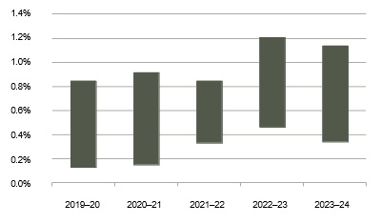
Comment: During 2023–24 we continued to deliver interest rate savings to our clients and the State through the centralisation of the State’s borrowing requirements. Depending on the term of the borrowing and an estimate of a standalone credit rating of our clients, this saving has been estimated to be between 0.34 and 1.13 per cent. See page 104 for more details.

Client Satisfaction
We strive to provide the best financial solutions for our public sector clients.
Target: 90% Client Satisfaction | Result: 100% Client Satisfaction
Image Caption: Client satisfaction results for the years 2019–20, 2020–21, 2021–22, 2022–23 and 2023–24. Data courtesy of Western Australian Treasury Corporation.
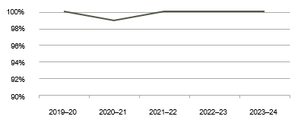
Comment: As an organisation we continue to deliver valued financial solutions. This year the public sector clients we surveyed confirmed their high level of satisfaction with the value we added to their projects, our overall capability, and the service we provided. See page 26 for more details.

<pp>14

Administration Cost Ratio
We are committed to delivering high-quality products and services while still being cost effective.
Target: Administration Cost Ratio < 0.050% | Result: Administration Cost Ratio = 0.043%
Image Caption: Administration Cost Ratio results for the years 2019–20, 2020–21, 2021–22, 2022–23 and 2023–24. Data courtesy of Western Australian Treasury Corporation.
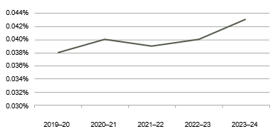
Comment: We continue to successfully manage and control our costs in the administration of our operations, ensuring our continued cost-effectiveness while delivering high-quality products and services. Our admin cost ratio was slightly up from the previous year due to client debt levels being lower than forecast. See page 106 for more details.

Pre-Tax Profit
We aim to maintain an adequate profit while delivering cost-effective products and services.
Target: Profit = $27.6 million | Result: Profit = $36.2 million
Image Caption: Pre-Tax Profit results for the years 2019–20, 2020–21, 2021–22, 2022–23 and 2023–24. Data courtesy of Western Australian Treasury Corporation.
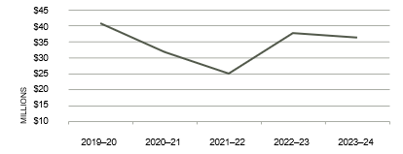
Comment: As the State’s central financial services provider, our objective is not to maximise profits but rather to deliver cost-effective products and services. Our pre-tax profit this year was above budget mainly due to lower than budgeted costs and higher interest received from investments as investment balances and interest rates were both higher than forecast. See page 61 for more details.

Employment Engagement Rating
We strive to create a working environment where all employees are engaged and supported.
Target: Rating > 65% | Result: Rating = 77%
Image Caption:
Employee Engagement Rating results for the years 2020–21, 2021–22, 2022–23 and 2023–24. Note: There was no survey in 2019–20. Data courtesy of Western Australian Treasury Corporation.
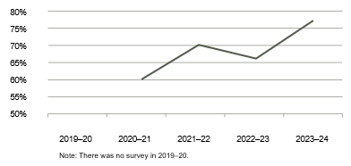
Comment: This year’s employee engagement result is a solid increase from last year (up by 11 per cent) and reflects the cumulative benefits of strategies implemented over the last two years to increase engagement levels across the organisation. These strategies continue to be developed and refined. See page 50 for more details.
<pp>15

Five-Year KPI Summary
Target | 2023–24 | 2022–23 | 2021–22 | 2020–21 | 2019–20
Estimated Interest Rate Savings > 0.00% | Yes | Yes | Yes | Yes | Yes
Assessment of Client Satisfaction | 100% | 100% | 100% | 99% | 100%
Administration Cost Ratio | 0.043% | 0.040% | 0.039% | 0.040% | 0.038%
Pre-Tax Profit | $36.2m | $37.6m | $25.0m | $31.7m | $40.7m
Employee Engagement Rating | 77% | 66% | 70% | 60% | n/a
n/a: not applicable

Five-Year Financial Summary
 | 2023–24  $m | 2022–23  $m | 2021–22  $m | 2020–21  $m | 2019–20  $m
Financial Performance
Profit Before Income Tax Equivalent | 36.2 | 37.6 | 25.0 | 31.7 | 40.7
Financial Position
Total Assets | 50,541.1 | 49,692.8 | 51,207.9 | 61,892.2 | 64,658.5
Percentage Change in Assets (%) | 1.7 | -3.0 | -17.3 | -4.3 | 8.7
Total Liabilities | 50,368.5 | 49,525.8 | 51,054.2 | 61,739.3 | 64,506.4
Equity | 172.6 | 167.0 | 153.7 | 152.9 | 152.1

<pp>16

About Our Organisation
Western Australian Treasury Corporation (WATC) is the State’s central financial services provider delivering financial solutions that benefit the Western Australian public sector.

Principal Activities
Funding and Debt Management
Our organisation plays a key role in financing the Western Australian public sector and delivering on the State's borrowing requirements through issuing and managing a range of debt securities in domestic and global capital markets. We provide debt products and services to support our public sector clients to achieve their financial goals.
Asset and Investment Management
We manage a large portfolio of financial assets and liabilities, as well as investing funds on behalf of the Western Australian Government and clients. We are experienced in providing secure investment solutions designed to meet our clients’ investment needs
Financial Advisory Services
Our specialist knowledge and experience in financial markets and financial risk management forms the basis of the advisory services we offer to our public sector clients. We provide expert, independent and professional advice to ensure that optimal financial solutions are delivered to our clients and the State.
Financial Risk Management
We operate in a dynamic financial market environment and manage a wide range of risks including market, credit, liquidity, funding, operational, reputational and strategic risks. We also provide a range of products and services to help our clients identify, measure and manage their exposure to financial and business risks.

Treasury Management Services and Systems
We have considerable experience and expertise in managing financial assets and liabilities. Our scale of operations and volume of activity in the financial markets enable us to deliver efficiencies and pricing benefits to our public sector clients. We also provide tailored treasury management services to suit client needs.

View more information about our organisation on our website:
Who We Are (watc.wa.gov.au)

Enabling Legislation
Our organisation was established on 1 July 1986 under the Western Australian Treasury Corporation Act
1986 (the Act) as the State’s central borrowing authority. Amendments to the Act in 1998 expanded our role
to include providing financial management services to the Western Australian public sector.

Responsible Minister
The Honourable Rita Saffioti BBus MLA: Deputy Premier; Treasurer; Minister for Transport; Tourism.

<pp>17

Organisational Structure
Image Caption: Diagram of WATC Organisational Structure. Kaylene Gulich PSM, Chief Executive Officer, oversees Financial Markets, Risk Management and Strategy. Stephen Morhall, General Manager Client Services, oversees Corporate Treasury Services, Advisory Services and Marketing and Communications. Ross Moulton, Chief Operating Officer, oversees Information courtesy of Western Australian Treasury Corporation.

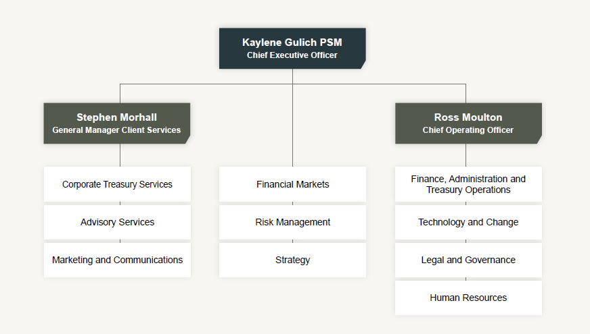
<pp>18

Functional Areas
Advisory Services
Providing financial risk and corporate finance advisory services to the Western Australian public sector. This involves assisting clients to make informed financial decisions that help them to achieve their objectives, while also realising the overarching goals of the State.
Corporate Treasury Services
Working in partnership with public sector clients to achieve sound financial outcomes by providing a comprehensive suite of high-quality, cost- effective financial products and services in debt finance, investments, foreign exchange, treasury management and financial risk management.
Finance, Administration and Treasury Operations
Providing accounting, administration, treasury operations, settlements, payroll and business support to the Board, Executive and business units, as well as key external stakeholders.
Financial Markets
Undertaking debt-funding activities in domestic and global capital markets. Managing financial assets and liabilities, our organisation’s liquidity portfolio, investments on behalf of clients, foreign exchange transactions, and economic and financial markets analysis.
Human Resources
Providing a strategic and operational human resources service to the Board, Executive, business units and employees that aligns with and supports our organisation’s strategic objectives, covering all stages of the employee life cycle.
Legal and Governance
Providing advice and guidance on complying with legislation, policies and sound corporate governance practices, and oversight of the origination and documentation of our organisation’s borrowings and other agreements, including financial market and client agreements.
Marketing and Communications
Assisting and supporting the development, implementation and management of our organisation’s marketing and communications activities.
Risk Management
Measuring and monitoring market, credit, operational and liquidity risk to prevent adverse outcomes for our organisation, providing guidance to the Executive and Board on all risk matters, and contributing to developing a good risk culture within the organisation.
Strategy
Developing and progressing strategic initiatives to improve efficiencies and financial outcomes from a State, client and organisational perspective, in relation to our financial markets and client services activities.
Technology and Change
Providing effective, efficient and secure information management, information systems and technology, and strategic delivery of key initiatives to support our business operations to deliver on business goals and objectives.
<pp>19

State Guarantee
Under Section 13(1) of the Act, the financial liabilities incurred or assumed by our organisation are guaranteed by the Treasurer on behalf of the State. This guarantee is secured upon the Consolidated Account of the State.

Changes in Written Law
During the 2022–23 financial year there was a consequential change to Section 9 of the Western Australian Treasury Corporation Act 1986 (WATC Act) pursuant to the Government Trading Enterprises Bill, which was assented to on 22 June 2023.

The Government Trading Enterprises Act 2023 (the GTE Act) came fully into effect on 1 July 2023.

Accordingly, Section 9 (1) (d) of the WATC Act now enables our organisation to, among other things, advise authorities on financial matters referred to in Section 137 of the GTE Act. This change provides flexibility for WATC to advise authorities on business risks associated with prescribed transactions, including hedging transactions pertaining to commodities.

Ministerial Directives
No ministerial directives were received during the 2023–24 financial year.

Credit Ratings
In line with the State’s credit ratings at 30 June 2024, our debt was rated as follows:

Rating Agency | Long-Term | Outlook | Short-Term
Moody’s Ratings | Aaa | Stable | Prime-1
S&P Global Ratings | AAA | Stable | A-1+

<pp>20
Board of Directors
The Board, with the agreement of the Treasurer, sets our strategic direction and establishes the policies and principles under which we operate.

Michael Barnes PSM, FIPAAWA
Chairperson
Mr Barnes assumed the role of Chairperson when he became Acting Under Treasurer in the Department of Treasury in 2014. Mr Barnes was appointed Under Treasurer in 2015. As Under Treasurer, he is the principal economic and financial policy adviser to the Government of Western Australia. He is also the Chairperson of WATC’s People and Remuneration Committee. Prior to joining the Department of Treasury in 1997, Mr Barnes worked in the Commonwealth Treasury, where he commenced his career as a graduate in 1992. Mr Barnes holds a Bachelor of Business degree with Honours in Economics, and was awarded a Public Service Medal for outstanding public service to State Government finances in Western Australia.

Michael Court
Deputy Chairperson
Mr Court was appointed to the Board as Deputy Chairperson in July 2017 and has been Deputy Under Treasurer at the Department of Treasury since September 2016. Mr Court has almost 30 years of public sector experience with a focus on economic policy and financial management issues. This includes extensive experience in providing advice to government on the budget, fiscal strategy, infrastructure policy and planning issues, as well as working across Commonwealth– State financial relations, energy market reform, competition and trade policy. Mr Court previously held positions in the Department of Foreign Affairs and Trade, Commonwealth Treasury and London Underground Ltd. He is a former Board Director of GESB and Horizon Power and is currently a member of the Bankwest Curtin Economics Centre Advisory Board.

Kaylene Gulich PSM
Chief Executive Officer
Ms Gulich commenced as CEO of WATC in February 2019. Ms Gulich has extensive experience in public policy, a broad knowledge of financial markets and considerable expertise in the Western Australian economy. She has previously held senior roles within the Department of Treasury, as the Executive Director of both the Economic, and Infrastructure and Finance business units. As well as being a member of CPA Australia and the Australian Institute of Company Directors, Ms Gulich is currently on the Board of Directors at the Australian Financial Markets Association, VenuesWest and the Western Australian Institute of Sport, and is the Treasurer for IPAA WA. Ms Gulich was awarded a Public Service Medal for outstanding public service to Western Australia through a range of roles.
<pp>21
View more information about our Board and its members on our website:
Board of Directors (watc.wa.gov.au)

Philippa Hobson
Director
Ms Hobson was appointed as a Director in February 2020 and is the Chairperson of WATC's Audit Committee and a member of the People and Remuneration Committee. Ms Hobson is a Risk Consulting Partner at RSM in Perth. Ms Hobson has over 25 years of internal and external audit and risk consulting experience. Ms Hobson works with clients in the public and private sectors, focussing on internal audit, enterprise risk management and governance services. Environmental, social and governance (ESG), process redesign and cultural reviews are also key services provided. Ms Hobson’s industry experience covers government, utilities, resources, not-for-profit and financial services. Ms Hobson is passionate about understanding how an organisation’s culture impacts its performance and conformance, and strives to support organisations optimising their potential.

Susan Murphy AO
Director
Ms Murphy was appointed as a Director in January 2019. As CEO of Water Corporation from 2008 to 2018, Ms Murphy led the multi-faceted organisation that supplies drinking water to two million customers and wastewater services across 2.6 million square kilometres. Ms Murphy played a pivotal role in ensuring sustainable services were maintained during a time of declining rainfall, growing population and scarce water supplies. In each year from 2009 to 2015, Ms Murphy was listed as one of the 100 most influential engineers in Australia by Engineers Australia. Ms Murphy was appointed an Officer of the Order of Australia in 2019 for distinguished service to the natural resources sector in Western Australia, and to engineering.

Wayne Zekulich
Director
Mr Zekulich was appointed to the Board as a Director in January 2023. He holds a Bachelor of Business and is a Fellow of the Institute of Chartered Accountants. Mr Zekulich is a consultant and non-executive director with substantial experience in advising, structuring and financing transactions in both the infrastructure and resource sectors. Mr Zekulich was previously Chief Financial Officer of Gindalbie Metals Ltd and, prior to that, Chief Development Officer of Oakajee Port and Rail. Currently, he is Chair of Pantoro Ltd, Jindalee Lithium Ltd, and Andro Pharmaceuticals Ltd in the UK.

<pp>22

Agency Performance
In this section:
Providing Value to Clients
Successful Financial Management
Optimising Our Performance
Image Caption: Decorative only. Exterior shot of Perth Arena. Image courtesy of Tourism Western Australia.



<pp>23

Providing Value to Clients
As the central financial services provider for the Western Australian Government, we continue to partner with public sector clients to successfully deliver sound financial management outcomes for their organisations and for the State.

Using our expertise in debt funding, investment, foreign exchange, financial advice and risk management, we continue to support our clients’ individual financial management requirements, delivered through our comprehensive range of high- quality, cost-effective financial products and services.

Debt Products and Services
A major benefit of our role as the central financial services provider for the Western Australian Government is the consolidation of the State’s borrowing requirements and the associated economies of scale this brings. As a result, we deliver significant interest rate savings to our clients and the State, providing debt funding at lower interest rates than clients could achieve by themselves.
Debt funding for clients this financial year supports the delivery of a range of State and local
government initiatives providing social and economic infrastructure across Western Australia, including:
        - supporting continuous improvement in our State’s environmental, social and governance outcomes;
        - maintaining, developing and building important economic and community assets, and infrastructure; and
        - purchasing essential plant and equipment.
Our range of debt products offer clients a variety of structures, maturities and repayment options. We also provide a complementary range of debt management services to support the effective management of clients’ debt portfolios. These include:
        - debt portfolio management services to manage interest rate risk in a manner appropriate to clients’ business needs; and
        - interest cost projection services to assist clients with budgeting and project evaluation.
We work collaboratively with our clients to ensure the most appropriate debt products and structures are recommended, and that solutions support client needs and are aligned with the overarching requirements of the State’s borrowing strategy.
View more information about our Loan Products on our website:
Loan Products (watc.wa.gov.au)
View more information about our Loan Services on our website:
Loan Services (watc.wa.gov.au)

KEY PERFORMANCE INDICATOR – ESTIMATED INTEREST RATE SAVINGS

$133 million +
During 2023–24 we continued to deliver interest rate savings to our clients and the State through the centralisation of the State’s borrowing requirements. Depending on the term of the borrowing and an estimate of a standalone credit rating of our clients, this saving has been estimated to be between 0.34 and 1.13 per cent. To monetise this, based on our total client fixed rate term debt, for a AAA-rated client equivalent, a conservative estimate of the minimum interest rate savings we delivered for the year is $133.9 million, representing a weighted average saving of 0.49 per cent. See page 104 for more details.

<pp>24

Supporting The Shire of Manjimup
WATC funding was used to assist with improving lighting on sporting ovals in Manjimup. The lighting at Rea Park and Collier Street has now been installed.
Image Caption: Aerial shot of lighting. Image courtesy of Shire of Manjimup.

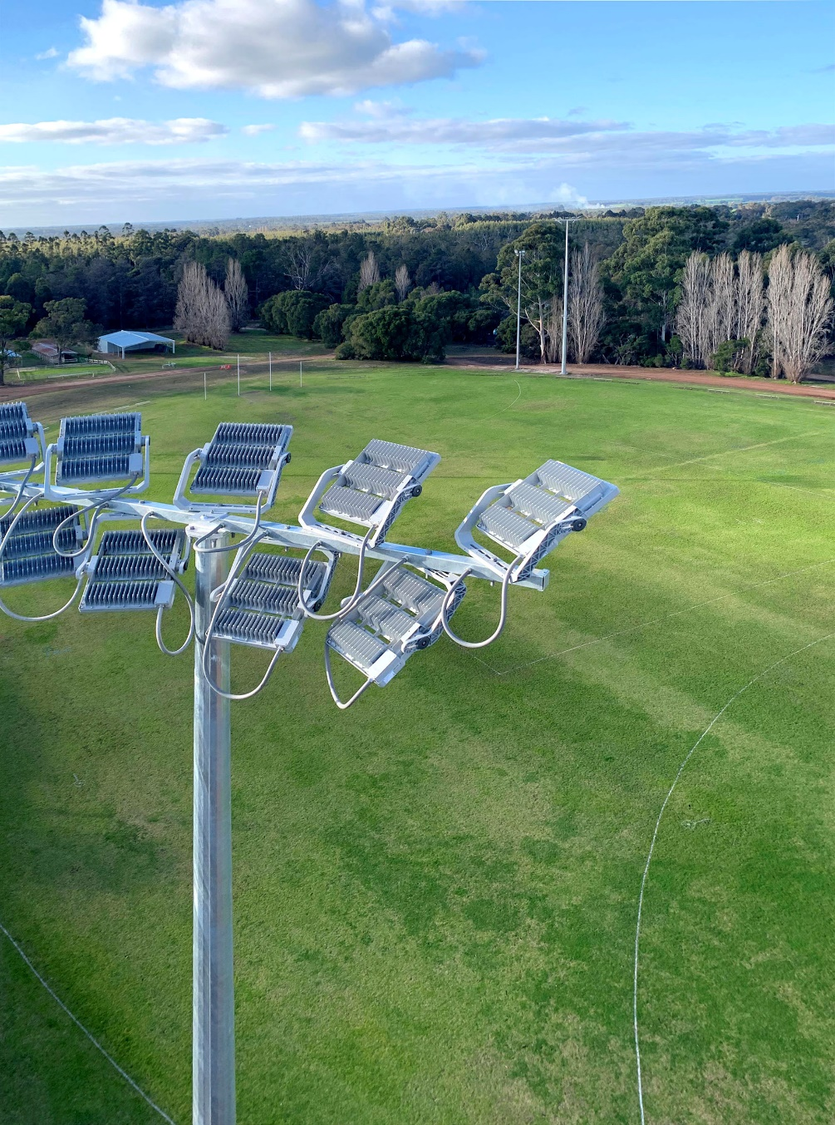

<pp>25

Client Debt
In line with the State’s borrowing program announced in the Western Australia State Budget 2023–24, we
originally anticipated an $857 million increase in client borrowings. However, as our clients’ requirements were less than expected at the start of the financial year, the actual increase was $480 million. Our total client debt outstanding at 30 June 2024 was $45.4 billion, up from $44.9 billion at the end of 2022–23.
We are also the primary provider of long-term debt funding for local governments across Western Australia. During 2023–24 we approved 39 loans totalling $65 million for 25 local governments, with our total local government client debt of $632 million at 30 June 2024. Through our responsible lending to local governments, we support local communities to deliver key infrastructure projects including housing, community facilities, and vital plant and equipment.
See page 113 for more detailed information on client debt outstanding at 30 June 2024.
Image Caption: Graph showing the increase in WATC Client Debt from 1986 to 2024. Data courtesy of Western Australian Treasury Corporation.

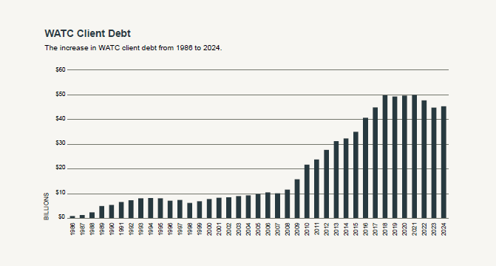

<pp>26

Advisory Services
We provide a broad range of corporate finance and financial risk management advisory services which are available to all Western Australian Government entities, local governments and public universities.

Our highly skilled and experienced team provides expert, independent and professional advice and is one of the largest teams of finance professionals dedicated to solely servicing the Western Australian public sector.

Through our collaborative approach, we strive to deliver better outcomes for our clients and for the State. Our broad range of advisory services, which are provided on a cost recovery basis, include:

        - Business Strategy Support: Our team specialises in financial analysis and provides actionable advice across various areas, including cost modelling, financial reviews, budget planning, environmental, social and governance strategy, and long-term financial planning.
        - Strategic Asset Investment Decision Support: In aiding informed investment decisions and value-to-state choices, we offer comprehensive cost modelling, value analysis, project finance expertise and alternative funding options. Our services include lease-versus-buy analysis, rigorous cost-benefit evaluations, comprehensive investment logic mapping, and guidance to ensure compliance with strategic asset management framework principles.
        - Procurement Support: For successful procurement, we assist with everything from constructing pricing workbook templates to evaluating complex pricing responses. Our independent modelling and commercial advice help optimise procurement strategies.
        - Corporate Finance: Our comprehensive corporate finance services cover valuations, cost of capital analysis, debt structuring reviews and advice on optimal funding mechanisms.
        - Risk Management Support: Clients benefit from our effective financial risk assessments and valuation expertise. Our detailed treasury policy review service helps our clients gain valuable guidance that strengthens their financial practices.

Demand for our advisory services continues to grow, which is a positive reflection of the quality and value provided by our team. During 2023–24 we completed 94 advisory engagements on behalf of 35 clients, close to double the number of engagements completed in the previous financial year.

View more information about our Loan Products on our website:
Advisory Services (watc.wa.gov.au)

KEY PERFORMANCE INDICATOR – ESTIMATED INTEREST RATE SAVINGS

100% Client Satisfaction
As part of our quality assurance framework, we request feedback from clients after completing an advisory
engagement. As with previous years, client feedback results for the 2023–24 financial year are extremely positive. Clients continue to be very complimentary in their feedback and express very high levels of satisfaction on the quality of advice we provide, the value we add to their projects, our overall capability and the services we deliver. The effectiveness of our Advisory Services team is also evidenced in the number of clients re-engaging our services to help them deliver new projects and initiatives.
<pp>27

Supporting The Western Australian Police Force
The Western Australian Police Force engaged our Advisory Services and Corporate Treasury Services teams for procurement advice and foreign exchange support to secure a new helicopter as part of the Force’s aircraft fleet upgrade. Pictured are members of our Advisory Services team at the commissioning event for the new helicopter in July 2023.
Image Caption: The new helicopter with members of the Western Australian Treasury Corporation’s Advisory Services team.



<pp>28

Supporting The Shire of Manjimup
WATC funding was used in conjunction with various grant funds and community donations to create a space for community groups. Buildings at the Pemberton Community Hub – Balang Miya have been renovated, redeveloped and repurposed to make a welcoming space for visitors.

Image Caption: One of the renovated spaces. Image courtesy of Shire of Manjimup.

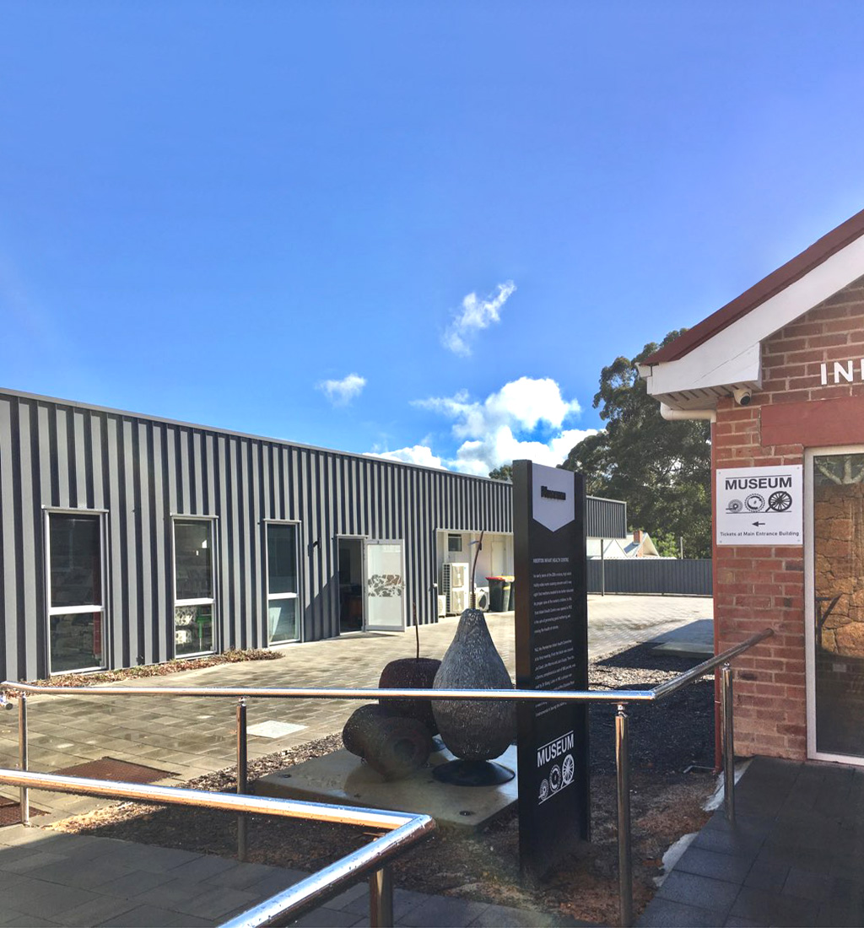

<pp>29
Case Study

Client Engagement

Road Safety Commission
Project:
Safety Camera Tender Pricing Comparator

Background:
With responsibility for minimising road trauma on Western Australia’s roads, the Road Safety Commission introduced a new Safety Camera Strategy to reduce the economic, social and emotional costs of road trauma within the State. Following an initial trial, the Commission, in collaboration with the Western Australian Police Force and the Department of Transport, sought to procure an initial fleet of trailer-mounted safety cameras.
Appointment:
The Commission requested our assistance to develop a deployment model that could be used to evaluate pricing responses stemming from a tender process.
Approach:
WATC participated in workshops with the Commission’s project team to consider the range of
pricing models for safety camera services and design a model capable of assessing a range of deployment
schedules. Having identified key drivers, we developed a pricing template for the tender process and compared tender pricing responses against the Commission’s desired deployment schedule using the model. The outcomes were then communicated to the evaluation panel.
Outcome:
Using the safety camera deployment model developed by our team, the Commission structured a deployment forecast to assess tender pricing responses to optimise value-to-state for the planned investment. The new model also allows the Commission to easily compare the financial impacts of any variations in the base-case deployment schedule.

“A very knowledgeable team who worked very collaboratively with the Road Safety Commission. Each
component of the work effort was delivered to a very high standard. Great work.”
Amanda Smith, Project Manager – Camera Procurement, Road Safety Commission

Image Caption: Image of the trial camera trailer courtesy of the Road Safety Commission.

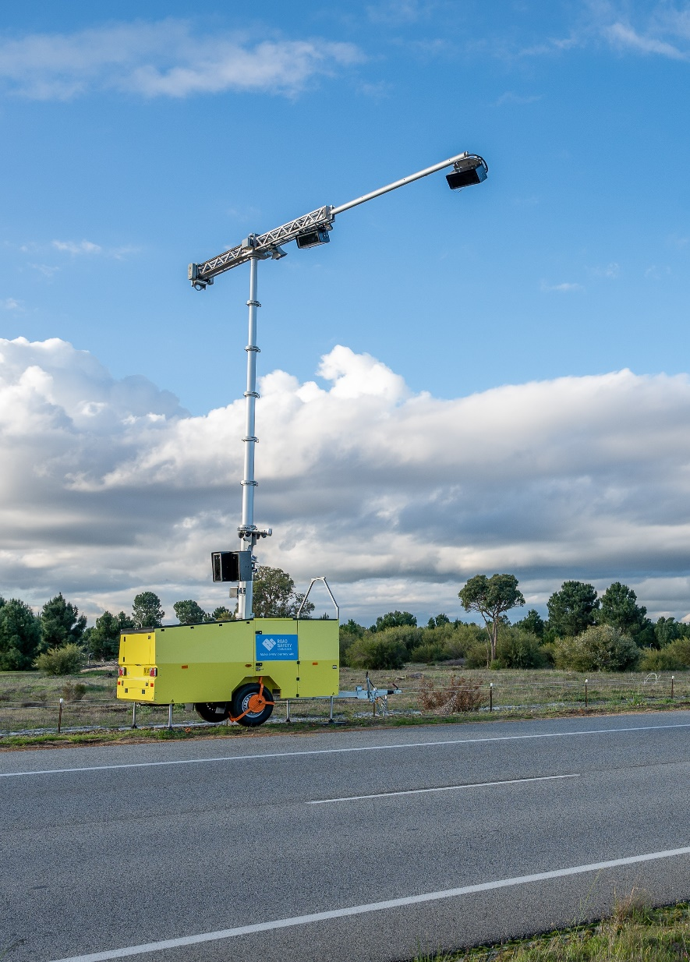

<pp>30
Case Study

Client Engagement

Department of Planning, Lands and Heritage
Project:
Housing Diversity Pipeline Option Cost Comparator

Background:
The Housing Diversity Pipeline program supports the Government’s $3.2 billion social housing investment. The initiative involves collaboration between government agencies, local government, the development industry and community housing providers to identify suitable development sites, provide incentives for innovative housing projects,
and deliver a mix of housing options across metropolitan and regional Western Australia.

Appointment:
The Department of Planning, Lands and Heritage sought our assistance to incorporate project delivery methods into a financial model that can assess value for the State under different approaches.
Approach:
We met with the Department, along with other stakeholders, to consider the key drivers for various project delivery approaches. Our team then developed a project delivery cash flow model incorporating scenario selectors. The selectors evaluate and stress-test different project delivery methods to assess the value-to-state impacts of
adjustments to assumptions and drivers.
Outcome:
We provided an effective tool for the Department and other Western Australian Government entities to facilitate and accelerate assessing the commercial viability of competing proposals to address the State’s social housing situation.

“The efforts of the WATC team have enabled the Department of Planning, Lands and Heritage to expedite preliminary financial modelling of prospective projects before investing in consultancy services.
This has helped the Department of Planning, Lands and Heritage to prioritise projects which meet the State’s objectives and achieve greatest public benefit.”
Ivan Story, Program Manager – Strategy and Engagement, Department of Planning, Lands and Heritage
Image Caption: Artist impression of housing. Image courtesy of the Department of Planning, Lands and Heritage.


<pp>31
Case Study

Supporting the Transition to Renewable Energy

Synergy
Project:
Large-Scale Battery Energy Storage Systems for Western Australia

Background:
Synergy is Western Australia’s largest electricity generator and retailer. In line with the State Government’s decarbonisation strategy and move to a more renewable energy future, Synergy is delivering several new battery storage solutions that are key to Western Australia’s transition to renewable energy. Two such initiatives in Kwinana and Collie were exposed to foreign currency risk as they both involved procuring from and contracting with overseas suppliers.

Appointment:
Synergy sought our assistance to manage the foreign exchange risk associated with these two projects.
Approach:
Working closely with the team from Synergy, we identified the foreign exchange risk associated with both projects and designed appropriate hedging strategies to manage it.
Outcome:
We executed more than A$950 million in foreign currency transactions to help Synergy successfully manage its foreign currency exposures and deliver these ground-breaking projects..

“WATC have provided significant value via their financial expertise in managing foreign exchange risk associated with Synergy’s battery energy storage systems.”
Victor Li, Manager Corporate Finance – Finance, Synergy
Image Caption: Large-Scale Battery Energy Storage Systems for Western Australia. Images courtesy of Synergy.

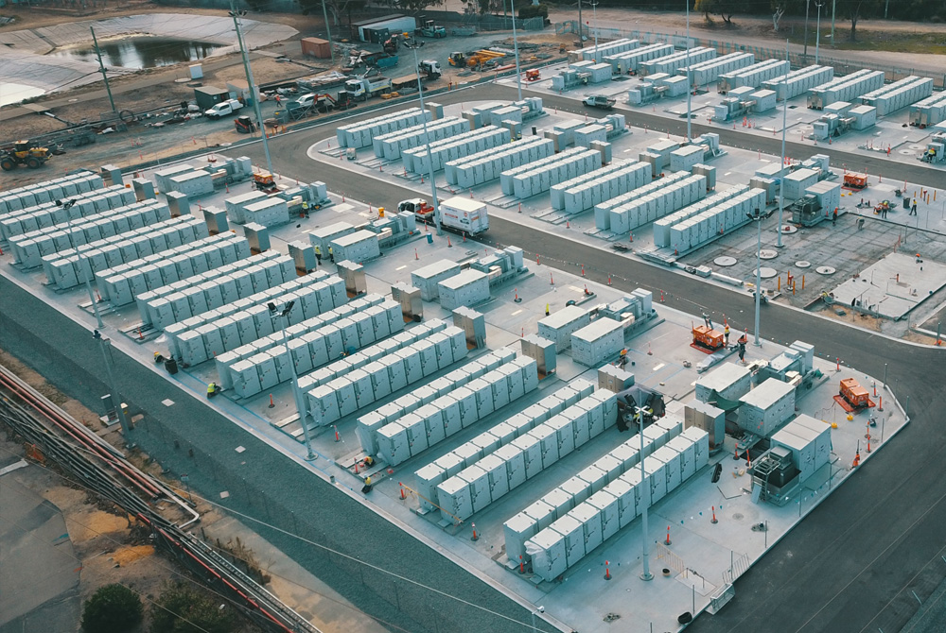
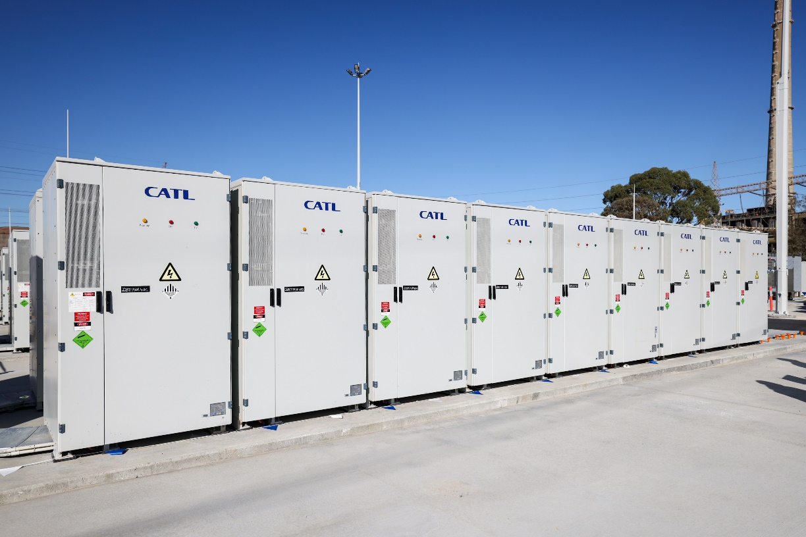

<pp>32

Foreign Exchange Services

Throughout the Western Australian public sector, our clients are exposed to financial risks which, if left unmanaged, can result in negative financial outcomes.

Foreign exchange risk is one of the business risks that our clients face and is required to be effectively managed in consultation with our organisation as part of the Treasurer’s Instructions.

Our foreign exchange services provide clients with access to a range of tools and products to help them successfully navigate the complexities of foreign currency exposures, minimise risk and develop effective risk management strategies.

Clients benefit from our expertise and experience in managing foreign exchange exposures as well as our direct access to wholesale foreign exchange markets, multi-currency funds settlement systems, capital markets information and treasury management systems.

Combining these systems and data with our experience and expertise ensures our clients are fully supported and aware of their foreign exchange risks and can make informed decisions in terms of materiality and management.

This financial year, we executed in excess of A$1.8 billion in foreign exchange transactions in eight currencies and on behalf of 15 clients, a substantial increase from the $550 million transacted on behalf of clients in the previous
financial year.

Government Trading Enterprise Reform
With the introduction of the Government Trading Enterprises Act 2023 (the Act) on 1 July 2023, we have been working closely with the Department of Treasury, assisting with the development of guidance notes to support the implementation of the Act. These guidance notes will assist Western Australian Government Trading Enterprises (GTEs) as they transition to the Act’s new requirements.

The overarching purpose of the Act is to standardise governance, strategic planning and accountability across GTEs and strengthen their connection with the Western Australian Government. A requirement of the Act is that GTEs must now consult with our organisation when determining the appropriateness of business and financial risk management strategies prior to undertaking any hedging transactions.

The Act also enables us to assist clients in evaluating and managing a wider range of business risks than previously permitted by our legislation.

We are continuing to develop and refine our approach as we help clients to identify and better understand these business and financial risks, quantify financial impacts and sensitivities, and explore the mitigation strategies available.

Asset and Investment Management Services
We assist in managing State and public sector client finances by providing investment products and treasury management services. These products and services are tailored to suit each client’s specific business requirements and aid the process of managing financial risks, including interest rate, liquidity and credit risks.

We also research and analyse investment opportunities to support clients in managing their short, medium and long-term investment needs.

Clients benefit from the considerable experience and expertise, systems, pricing and oversight that come with our scale of operations in the financial markets.

Managed Investments
Our total client funds managed at 30 June 2024 was $8.4 billion (up from $6.7 billion the previous year) across five investment portfolios. We continue to manage each of these portfolios in accordance with client-approved policy
frameworks that include defined risk parameters and performance benchmarks. We also provide
back-office trade capture and reporting on treasury management services for two clients.

<pp>33
WATC FOCUS

Increasing Awareness and Understanding of Financial and Economic Issues
Objective:
To promote, educate and assist clients across the Western Australian public sector on sound financial management and the economic environment.

Outcome:
We engaged over 400 client contacts through our education and training program, with attendee
numbers significantly higher than in previous years. Attendees continue to provide very positive
feedback, with many advising that attending our seminars has improved their understanding of
financial risk management.

Foreign Exchange Seminars
Each year we offer a series of foreign exchange educational seminars which are available to all Western Australian public sector entities and local governments. These seminars promote awareness and understanding of foreign exchange risk management issues. This year, we held three
foreign exchange seminars with a total of 70 client contacts attending from organisations across the
public sector.

Economic Insights
Our in-house team of economists produce a wide range of publications including regular market
updates, and commentary and analysis of key economic data in Australia. These publications are
available on our website, with some publications available through our mailing lists.

Our economists also deliver regular economic presentations to our clients’ boards and finance teams.
A highlight this year was their online economic presentation providing insights into the economic
challenges and opportunities for Western Australia in the global transition to net zero. The event was
very popular with over 240 client contacts from more than 60 different government entities joining
the session, representing general government, local government and Government Trading Enterprises.

Financial Modelling
At the invitation of the Department of Finance, our Advisory Services team shared their knowledge
of financial modelling and bid construction and evaluation to the Department of Finance’s procurement and project management teams. During the financial year our team conducted three of these presentations with a total of 64 attendees participating.

Industry Events
We hosted our public sector clients at various industry events throughout the financial year. The selected events included presenters and topics that aligned with our products and services, and the roles of the client contacts who attended.

<pp>34
CASE STUDY

Future Health Research and Innovation Fund Investment Strategy Review
Department of Treasury

Project:
Future Health Research and Innovation Fund

Background:
The Future Health Research and Innovation Fund was established to provide a secure source of funding to drive health and medical research, innovation and commercialisation, and through these activities improve the health and prosperity of all Western Australians.

Appointment:
As investment manager for the Fund, we were requested by the State’s Expenditure Review Committee to support the Department of Treasury to review the fund’s investment objectives and investment strategy.

Approach:
The previous portfolio structure comprised mainly government bonds issued by the Australian states
and territories, and floating rate notes issued by the four major Australian banks. Our analysis modelled the risk-and-return characteristics of various portfolio structures containing a broad range of asset classes. Supported by our analysis, the Department of Treasury’s recommendation for a new investment strategy was approved by the Expenditure Review Committee. This strategy incorporates a portfolio of fixed and floating-rate corporate debt securities and will be benchmarked to a blend of publicly available fixed-income indices.

Looking Forward
Financial Management Regulations
We will assist the Department of Treasury to review the Financial Management Regulations for investments to ensure they are contemporary and support sound financial risk management outcomes for
our clients and the State.

Government Trading Enterprise Reform
We will continue to enhance our service offering in support of the Government Trading Enterprise reforms. We will also review our legislation in preparation for the next tranche of the reform rollout.

<pp>35

Successful Financial Management
We successfully delivered on the State’s 2023–24 borrowing requirements and continued to meet our clients’ evolving debt financing needs in what has been another year of unpredictable and challenging global economic and financial conditions.

Despite these challenging global conditions, we continue to be able to access and source funding from domestic and international financial markets, with our new issuances attracting strong investor demand. Our ability to complete our funding task is well supported by the State’s sound fiscal position, with our low net-debt profile and top credit ratings being a positive story for our investors.

We are continually monitoring the ever-changing global economic and financial market environment and remain vigilant to identify opportunities that present and manage any challenges that may impact our future financing requirements. We remain confident in the State’s economic resilience and our continued ability to deliver on the State’s and our clients’ future financing needs.

Economic and Market Conditions
Global economic growth moderated further in 2023–24, with mixed performance across the major economies.

In the US, gross domestic product (GDP) growth accelerated in the second half of 2023 with more moderate growth into 2024, with ongoing increases in private consumption and investment. US labour market conditions clearly eased towards the end of 2023–24 but remained sound, with the ongoing rise in employment and the still low unemployment rate. GDP growth in the euro area and UK improved in early 2024, after a weak second half of 2023. Japanese growth remains soft, with GDP falling in the March quarter.

After accelerating in the first three quarters of 2023–24, Chinese GDP growth slowed towards the end of the financial year to reach just 4.7 per cent, which is quite weak by historical standards, despite stabilisation measures taken by its government and central bank.

Troubles in China’s property sector continued in 2023–24, though China’s demand for iron ore remained strong throughout the financial year.

Inflation rates fell further across the advanced economies during 2023–24 but remained above the respective central bank targets in most cases. The disinflation process slowed in the first half of 2024, especially in the US. The escalation of the conflict in the Middle East and output cuts by OPEC+ resulted in oil prices remaining elevated throughout 2023–24.

As a result, central bank interest rates remained elevated, despite the start of the monetary policy easing cycle in Canada and continental Europe. The elevated policy rates, combined with heightened inflation expectations, were reflected during 2023–24 in the relatively high levels of government bond yields including further increases in the US.

In Australia, real GDP growth slowed over the course of 2023–24 and remained negative in per capita terms. The weakening performance of the Australian economy was due to softer household

<pp>36

consumption growth, a decline in private and public gross fixed capital formation, and a fall in exports. Despite weaker economic growth, Australian labour market conditions remain strong, with employment rising by a cumulative 389,000 over the course of the last financial year. The unemployment rate picked up from the multi-decade lows of mid-2023 but remains modest at 4.1 per cent in June 2024.

Australian consumer price index inflation continued to ease for most of 2023–24, before the disinflation process stalled above the Reserve Bank of Australia’s (RBA) target band of 2–3 per cent, with services price inflation remaining elevated. Given this, the RBA, having increased its cash rate target to 4.35 per cent in November 2023 has maintained interest rates at a decade high rate.

Western Australian state final demand rose by 4.1 per cent over the year to March 2024 – by far the most of all the states – while merchandise exports remained solid at A$251.1 billion in 2023–24. Labour market conditions remain strong, with Western Australia having the lowest unemployment rate of all the mainland
states of 3.7 per cent and the strongest annual employment growth over the year to June 2024. All this is reflected in the outstanding fiscal position of the State, with the sixth consecutive net operating surplus in 2023–24 and the lowest net debt to gross state product profile of all the Australian states.

Financial Market Activities

Borrowing Program
Following the release of the Western Australia State Budget 2023–24, we announced our borrowing program for the financial year. An estimated $5.9 billion in term funding requirements was highlighted to meet our client borrowing and refinancing requirements. Over the course of the financial year our gross issuance was $6.6 billion, an increase from our original estimated program, reflecting pre-funding of upcoming bond maturities in 2024–25.

Delivering on Client Requirements
In delivering on the borrowing requirements of the State and our clients, we were active across all elements of financial markets through reverse enquiry, tenders and syndications. In doing so we successfully completed our yearly funding task, which included the successful issuance of:
        - New Floating Rate Notes
On 14 November 2023 we simultaneously issued by syndication two new floating rate notes (FRNs) with 21 February 2029 and 21 February 2031 maturities. The issues attracted strong investor support with the total bids across both exceeding $3.4 billion. The final issue volume for the 2029 FRN was $1.0 billion, allocated to 17 institutions with 93.5 per cent going to domestic investors. The final issue volume for the 2031 FRN was also $1.0 billion, allocated to 13 institutions with 100 per cent going to domestic investors.
        - New Benchmark Bond
On 17 May 2024 we issued by syndication a new fixed rate benchmark bond with a 4.50 per cent coupon and a 21 July 2032 maturity. The new issue found strong investor interest with total bids exceeding $4.0 billion from 44 bidders, with the final issue volume of $1.35 billion allocated to 40 investors. Domestic investors included asset managers, banks and other official institutions. Offshore investors also participated strongly with over 24 per cent of the issue placed with various international central banks, fund managers and commercial banks.

Funding for liquidity and short-term requirements continue to be met through our Domestic Short-Term Inscribed Stock and Euro Commercial Paper Program.

State Bonds
We offer state bonds to individual investors and those seeking to purchase them as a designated investment as part of their application to migrate to Australia. At 30 June 2024 there was $163.5 million in State Bonds outstanding.

View information about Western Australian State Bonds on our website:
Western Australian State Bonds (watc.wa.gov.au)

<pp>37

Image Caption: Graph showing the WATC Maturity Profile as at 30 June, split into Short-Term Inscribed Stock, FRNs, Green Benchmark Bond, Benchmark Bond and State Bond categories. Data courtesy of Western Australian Treasury Corporation.

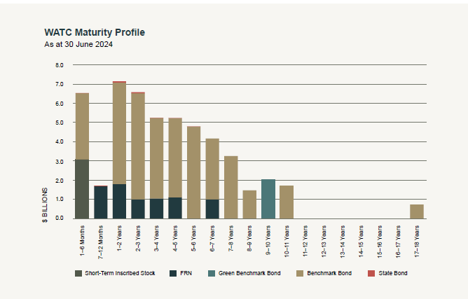

Credit Ratings
Under the Western Australian Treasury Corporation Act 1986 all of our financial liabilities are guaranteed by the Treasurer on behalf of the State. At 30 June 2024, our borrowings were afforded the highest credit ratings of AAA by S&P Global Ratings and Aaa by Moody’s Ratings.
Moody’s Ratings revised Western Australia's credit rating to Aaa in July 2023, highlighting our State’s ongoing strength in financial management, sustained budget surpluses and the decreased debt burden. Western Australia is now the only Australian state or territory with a triple-A credit rating from both major international rating agencies.
See page 19 for more information about our credit ratings.

<pp>38

Sustainability Bond Framework Annual Report
Following last year’s release of our Sustainability Bond Framework and the successful launch of our inaugural green bond, in December we published our first Sustainability Bond Framework Annual Report.
Importantly, the annual report consolidates our journey to becoming a committed participant in the sustainable finance market and showcases our State’s progress towards accelerating climate outcomes through the projects funded by our green bond. The report also delivers on our commitment to transparent and timely reporting.
Through the report we demonstrate the alignment between the State Government’s sustainability strategy and the 10 projects initially selected for inclusion within the green bond project pool. These projects were chosen based on three key environmental themes strongly connected to priority policies of the Western Australian Government. Each project will contribute significantly to achieving meaningful, positive change.
A key component of the report is the allocation of green bond proceeds by project with detailed project descriptions, delivery statuses and impact indicators included. Verification provided by an independent assurance provider is also included.
The report focuses on progressing renewable energy generation through the State’s main electricity grid. A minimum of 50 per cent of the proceeds over the life of our green bond are

Projects in Green Bond Within Prioritised Western Australian Government Environmental Themes
1 | Reducing Emissions from Electricity Generation | Renewable Energy | Standalone Power Systems
 |  |  | Solar Schools Program
 |  |  | Energy Efficiency
 |  | Energy Efficiency | Large-Scale Batteries
 |  |  | Advanced Metering Infrastructure
 |  |  | LED Streetlights
2 | Transport Infrastructure to Support Net-Zero Transition | Clean Transportation | METRONET
 |  |  | Electric Vehicle Initiatives
 |  |  | Active Infrastructure
3 | Enhancing Climate Adaptation and Resilience | Sustainable Water | Adaptation and Resilience Sustainable Water Renewable Energy Powered  Desalination Plant

<pp>39

[carried on from page 38] committed to projects that reduce emissions from electricity generation. This supports the Western Australian Government’s commitment to phase-out State owned coal-fired power generation by 2030 and reduce own-source emissions to 80 per cent below 2020 levels.

While the report connects a selection of State Government projects for funding under the Framework, there are many other transformational projects that continue to be funded as part of our standard benchmark bond lines. The report also signals our intention to stay active in the sustainable bond market and outlines how we will continue to work with our government partners and explore opportunities for future issuances.

Find out more about our Sustainable Finance Program on our website:
Sustainable Finance Program (watc.wa.gov.au)

Update to the State’s ESG Information Pack
We continue to take a leading role on behalf of the Western Australian public sector in communicating
to investors the State’s environmental, social and governance (ESG) credentials. In July 2023 we produced and coordinated the release of the second annual update to the Western Australian Government’s ESG information pack: Supporting Continuous Improvement in ESG Outcomes for Western Australia.

The publication provides updated information on key ESG initiatives being progressed by the Western Australian Government over the previous 12 months, including new initiatives contained in the 2023–24 State Budget.

This publication series is part of our commitment to transparency and ensuring we provide timely and relevant information to keep our investors and financial markets updated and informed.

View the complete ESG Information Pack Series on our website:
WA's ESG Commitment (watc.wa.gov.au)

Green Bond Wins Industry Awards
Every year KangaNews, a specialised information service covering the Australian and New Zealand debt markets, awards the year's most outstanding institutions, deals and people. The KangaNews awards are decided solely on the votes of hundreds of market participants.

This year our green bond won the KangaNews Award 2023 for Australian Sustainability Bond Deal of the Year. Our Chief Executive Officer, Kaylene Gulich, was also named one of their Market People of the Year.
These awards recognise the very positive view that both market participants and our peers have of our
first green bond issuance. Similarly, they further validate WATC’s role in supporting the Western Australian Government’s delivery of positive environmental, social and governance outcomes.

Term Funding Requirement | 2023–24 $b | 2024–25 $b | 2025–26 $b | 2026–27 $b
New Money Program (Est.) | 0.5 | 0.7 | 0.5 | 0.6
Projected Maturities | 5.3 | 5.9 | 7.4 | 6.0
Less Pre-Funding | -0.5 | 0.0 | 0.0 | 0.0
Total Maturities + New Money | 5.3 | 6.6 | 7.9 | 6.6
Debt Repayment | 0.0 | 0.0 | 0.0 | 0.0
Total Term Funding | 5.3 | 6.6 | 7.9 | 6.6

Looking Forward

ESG
We will continue to take a leading role in coordinating and evolving the publication of information on the State’s journey to improving environmental, social and governance (ESG) outcomes. Specifically, we will be delivering an information pack for investors on the topic of decarbonisation.
We will continue to work with our stakeholders in identifying opportunities to expand our Sustainable Finance Program through the issuance of a second ESG-labelled bond. We will also consider adding social projects in future labelled issuances.

<pp>40

Investor Tour
As part of our role to promote investment in Western Australia, in October 2023 we hosted
national and international fixed-income investors in conjunction with the Commonwealth Bank of Australia’s 2023 Global Markets Conference.

The two-day Western Australian component of the conference showcased the strength and diversity of our economy with a full program of experiences. Delegates and guests were welcomed by the Honourable Rita Saffioti BBus MLA, Deputy Premier and Treasurer of Western Australia, who provided an introduction and overview of our great State which laid the foundation for a successful event.

Our theme – ‘Western Australia, it’s like no other’ – was reinforced through presentations from Western Australian government and business experts, and on-site visits that showcased our traditional strengths in mining, as well as other existing, new and emerging industries. Delegates were able to gain a greater understanding of the diversity of our State’s economy and experience our cultural heritage.

We received very positive feedback from attendees noting a deeper appreciation of Western Australia and agreeing that it truly is a state like no other.

<pp>41
          - Looking Forward

Economic Outlook
Global economic growth is expected to remain moderate at around three per cent in 2024–25. Despite recent upgrades to the global outlook, this forecast is surrounded by significant risks. Ongoing divergence is likely across the advanced economies, with a slowdown anticipated for the US and China, and a
recovery predicted for Europe and Japan.

The degree of uncertainty surrounding the global outlook remains high with several other contributing factors:
        - Geopolitical risks remain elevated due to the ongoing war between Russia and Ukraine as well as the escalation of conflict in the Middle East. Both pose an upside risk to oil prices and increase the likelihood of supply chain disruptions.
        - While central banks in most advanced economies are expected to embark on, or in some cases continue, monetary policy easing, the timings and scale remain uncertain. It will also take a while for the impact of interest rate cuts to run through the economies.
        - Despite monetary easing, interest rates are likely to remain higher than before COVID-19. It is uncertain how businesses and households will adjust to this new regime. Australian GDP growth is forecast to accelerate from late 2024. This is mainly due to improving household demand, supported by a rise in real disposable income amid an expected decline in inflation, even though inflation forecasts remain above the RBA’s target range until mid-2025. However, in line with the international experience, inflation could prove stickier than currently expected. Given this, the outlook for interest rates in 2024–25 is uncertain, with the first rate cut priced in by markets only for the second half of 2024–25. This uncertain environment could weigh on the spending decisions of households and businesses during the year ahead.
Western Australian economic growth is expected to accelerate slightly in 2024–25, reflecting stronger exports due to new mining projects coming online. Household consumption and dwelling investment are anticipated to grow at a similar pace to 2023–24, while business investment is expected to consolidate following another year of strong growth. The State’s strong economic fundamentals and outstanding
fiscal position mean that Western Australia is well equipped to face the mounting global headwinds.

<pp>42

Looking Forward

Borrowing Program for 2024–25
The new money program for 2024–25 is estimated at $600 million. In addition, there is approximately $5.3 billion of maturing benchmark bonds and floating rate notes. This results in an estimated gross term funding
program of $5.9 billion for 2024–25.

The sourcing and composition of our funding is subject to market conditions and the borrowing requirements of our clients. Our forecast borrowing program across the forward estimates period following the release of the Western Australia State Budget 2024–25 is as follows:

Forecast Borrowing Program
Term Funding Requirement | 2024–25  $b | 2025–26  $b | 2026–27  $b | 2027–28  $b
New Money Program (Estimated) | 0.6 | 1.6 | 2.8 | 1.3
Projected Maturities | 5.3 | 7.1 | 6.2 | 5.2
Total Term Funding | 5.9 | 8.7 | 9.0 | 6.5

Looking Forward

Funding Strategy for 2024–25
We plan to deliver on the State’s funding and debt management requirements for 2024–25 by:
        - Consider opportunities to issue a minimum of one new floating rate note maturity in the 5–7-year maturity range.
        - Where able, issue into outstanding floating rate note maturities in response to investor demand and to meet our clients’ floating rate borrowing requirements.
        - Build volume in existing benchmark bonds and support activity where possible to enhance liquidity in those lines.
        - Seek to establish a new benchmark bond line with the aim of extending the maturity profile of our existing benchmark curve beyond the 2034 maturity. This will include considering opportunities for expanding our Sustainable Finance Program through the issuance of a second ESG-labelled bond.
View our current Borrowing Program and Funding Strategy on our website:
Borrowing Program (watc.wa.gov.au)

<pp>43

Supporting the Town of East Fremantle
WATC funding was used in conjunction with Lotterywest grants to assist the Town of East Fremantle with the East Fremantle Oval Precinct Redevelopment, which included upgrades to East Fremantle oval, the adjacent skate park and playground.
Image caption: Playground at the East Fremantle Oval Precinct. Image courtesy of the Town of East Fremantle.


<pp>44

Optimising Our Performance
During another year of challenging global economic and financial conditions, we continued
to deliver on our stakeholders’ requirements and achieve our key performance metrics
while operating within relevant legislative, governance and compliance requirements.

We operate in a dynamic and constantly changing environment that produces both risks and opportunities, necessitating a flexible approach to the management of our operations. We assess potential risks and opportunities in accordance with the Western Australian Treasury Corporation Act 1986 and our Board-approved risk management and compliance framework, which provide a clear governance structure for operational decision making.

Risk Management
Risk is inherent in all our functions, and the effective management of risk is integral to achieving our business mandate and strategic objectives. Our Board regularly considers its risk appetite and assesses our risk management process, systems and reporting structures to ensure they remain appropriate. Our Risk
Appetite Statement identifies a range of material risks and clearly articulates our Board’s appetite for each of them with specific target statements and risk measures.

Our Risk Management Framework outlines our overarching approach to managing risk and details the set of components that provide the foundations and organisational arrangements for designing, implementing, monitoring, reviewing and continually improving risk management throughout our organisation.

We use a Risk Taxonomy to categorise our material financial and non-financial risks, which are constantly monitored, evaluated, managed and reported on.

As an organisation, we continue to invest time and resources in ensuring our risk management practices are contemporary and evolve in accordance with market best-practice. Key highlights in risk management this year include:

        - Model Risk Management Framework: Implementing a new quality-assurance process and more rigorous framework for identifying, testing and developing models used in the operations of our business.
        - Cyber Security: Remaining ever vigilant to cyber security threats and maintaining a disciplined focus on ensuring the security of our systems.
        - Financial Risk Management Policies: Maintaining our ongoing program to review, assess and update our key financial risk management policies to ensure they are clear, easily understood and effective.
        - Operational Resilience: Continuing to test and refine our business continuity framework to ensure that we can effectively respond to business disruptions.
        - Lending to Local Governments: Embedding improvements in our local government loan approval process to deliver more timely assessments of loan applications for our clients.

<pp>45

Managing the State’s Liquidity
A key factor rating agencies take into consideration when determining credit ratings is liquidity risk. Western Australia’s exceptional liquidity coverage is cited as a major strength that has contributed to our State receiving triple-A credit ratings from both major international rating agencies. We work collaboratively with the Department of Treasury and our clients to successfully manage and maintain our State’s financial assets and liabilities. Additionally, our Board sets key metrics, which it monitors closely, to ensure effective balance sheet management and sufficient liquidity levels. During the 2023–24 financial year, our organisation and the State both maintained elevated levels of liquidity, ensuring targets for our debt metrics were met.

Improving Our Operations
We completed an in-depth operational review this year to ensure we continue to meet the evolving
financial needs of our clients and the State and remain agile to the challenges and opportunities of
a changing market.

Based on the results of our review, we are refining our organisational structure to improve alignment, enhance key functions and allow for continued growth and optimisation as the State’s central financial services provider.

These refinements will also support planned new strategic initiatives, ensuring we remain focussed on meeting the financial needs of the Western Australian public sector, now and into the future.

16%
Debt Maturing Within 12 Months
Target: Less than 20%
Result: Target achieved

236%
Liquid Asset Portfolio Cover
Target: Greater than 100%
Result: Target achieved

Looking Forward

Balance Sheet Reform
We will continue to review our balance sheet management practices to ensure they remain appropriate to meet our objectives under different funding tasks and market conditions.

Organisational Adaptability
We will continue to implement refinements to our organisational structure and operations to enhance our key functions, activities and resources, allowing for continued growth and optimised performance.

KEY PERFORMANCE INDICATOR – ADMINISTRATION COST RATIO OF 0.043%
This ratio allows us to monitor our administrative efficiency and the cost effectiveness of funding client borrowing by calculating the average administrative on-cost to be covered by our clients. In 2023–24 we achieved an administration cost ratio of 0.043 per cent, which was below our target of less than 0.050 per cent, affirming our cost-effectiveness while delivering value to clients and the State. See Key Performance Indicators on page 106 for more details.

<pp>46

Disclosures and Legal Compliance
In this section:
Managing Our Information Assets
Our People
Board of Directors’ Governance
Board Committees
Legislation
Corporate Governance

Image Caption: Decorative only. Castle Rock, near Dunsborough. Image courtesy of Tourism Western Australia.



<pp>47

Managing Our Information Assets
Information is critical in supporting our business activities and is managed in accordance with the State’s records management requirements.

Information Management
Data, information and records are all managed as valuable assets, critical to the success of our operations. All information assets are captured and managed according to our business needs, ensuring relevant information is readily accessible and appropriately secured.

We have an approved recordkeeping plan in accordance with Section 19 of the State Records Act 2000 (State Records Act), which meets the requirements of Standard 2, Principle 6. We manage our records under the Recordkeeping Plan (RKP) 20200032, which was approved by the State Records Office of Western Australia on 26 March 2021 and is valid until March 2026.
Our information management policies and procedures are regularly reviewed and updated as required, as part of our ongoing information governance processes.

Our organisation continues to adopt a flexible working environment including remote working opportunities. These opportunities are further enhanced through our applications for managing digital information in a safe and secure manner.

Recordkeeping Training
Our recordkeeping induction program for new team members continued with all 12 new starters completing the program within two weeks of their commencement date in line with our policy. Our recordkeeping induction program is a combination of:
        - An initial introduction and overview of our records and information framework, including where and how to find information.
        - An audio-guided online learning module introducing our information management policy and outlining employee responsibilities and requirements. Once the module is completed, a quiz is used to embed understanding.
        - A facilitated practical workshop on how to use our electronic document records management system. After completing the workshop, our information management service provider, Information Proficiency, meets with new team members to see how they are finding using the system, answer any questions and obtain feedback on their induction.
In accordance with our policy, our people undertake records awareness refresher training every two years. During the year we identified specific employee needs in this area and updated our refresher training program accordingly.

Digital Information Management Strategy and Roadmap
In 2022 we undertook extensive research to determine the best way to implement digital information technologies and applications as part of our high-level Digital Information Strategy and Roadmap. We are now in the fifth and final stage of this roadmap.
Key achievements this year include progressing our employee rollout and change management program, with 80 per cent of employees now migrated to SharePoint Online. Halfway through the rollout, a solution review was completed to ensure specified goals were met and the solution was fit for purpose. In addition to the employee rollout, the project team has implemented solutions for vendor management, policies, email management and templates.

<pp>48
Image caption: Roadmap to Compliance. Maps the various Roadmap to Compliance stages including Stage 1: Identify; Stage 2: Determine; Stage 3: Build; Stage 4: Enable; Stage 5 Transition.
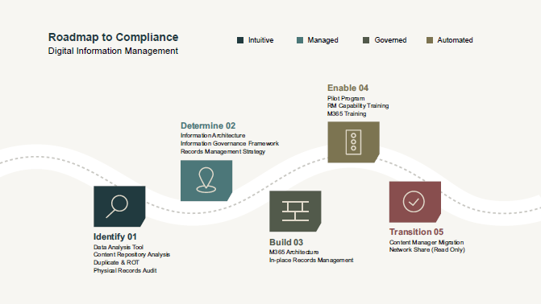

Annual Report Wins Award
Our previous annual report received a Silver Award in the Government Trading Enterprise category at
the Institute of Public Administration Australia WA’s 2023 WS Lonnie Awards.

This annual event recognises excellence in annual reporting across the Western Australian public sector and promotes and encourages accountability and transparency, themes that are central to good governance. Each year, an independent judging panel awards gold, silver and bronze medals across a range of government categories after assessing eligible annual reports against the selection criteria.

One of our core values is integrity and we strive to be open, honest and accountable in all aspects of our business. We have consistently applied this value to our annual reporting approach and, with many of our previous annual reports also having won Lonnie Awards, this is a great recognition of our delivery of this aspect of our values.

Freedom of Information
The Freedom of Information Act 1992 (FOI Act) enables the public to apply for access to documents
held by our organisation. Guidance on how to apply for and obtain requested documents is set out in our
Information Statement, which is available via our website. The statement is prepared in accordance
with the requirements of the FOI Act and is regularly reviewed and updated.

We received one FOI application and one third-party consultation this financial year. These were both
processed in accordance with the FOI Act and our FOI Policy, and within the required timeframes.

View our Privacy Statement and Public Interest Disclosure on our website:
Privacy (watc.wa.gov.au)

<pp>49

Complaints
We are committed to providing an accessible, fair and efficient complaints management process. Our Complaints Management Policy is informed by guidance issued by the Ombudsman Western Australia. This includes the appointment of a dedicated Complaints Officer who is responsible for impartially assessing complaints and notifying our Chief Executive Officer about any received and progress towards a resolution. The policy stipulates strict timeframes for responding to and resolving complaints. We regularly review our complaints policy to ensure it remains current and is easy for users to navigate. There are multiple ways to lodge a complaint, including an online form on our website, by mail, email or in person.

Complaints at our organisation are viewed as an opportunity to improve our business operations and services provided. We received one complaint in August 2023 made by a bond holder against our registry services provider, which was resolved to the full satisfaction of the complainant.

Looking Forward

Digital Information Management
Completing our Digital Information Strategy and Roadmap, and transitioning to support and develop the solution as it is embedded across our organisation.

Privacy and Responsible Information Sharing
The Western Australian Government is introducing legislation to protect the personal information of Western Australians and to facilitate responsible use and sharing of government information. We will be implementing the Privacy and Responsible Information Sharing Framework to support the upcoming legislation.

Supporting the Shire of Perenjori
WATC funding was used to assist the Shire of Perenjori’s housing construction.

Image caption: The constructed house. Image courtesy of the Shire of Perenjori.
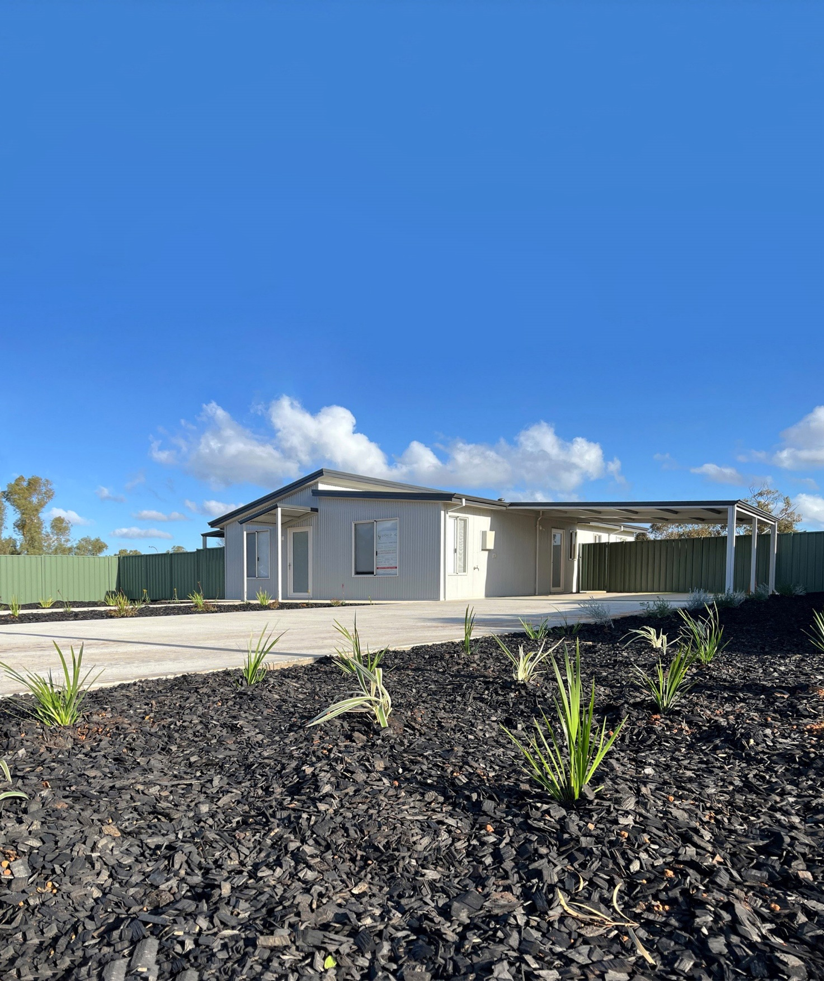

<pp>50

Our People
We continue to develop our existing team at the same time as building out the depth and
capacity of our workforce to respond to current and future challenges.

Improving Employee Engagement
Our annual Employee Engagement Survey provides valuable insights into the connection our people have
with the values and objectives of our organisation.

The survey is curated to measure levels of employee motivation, pride and commitment, and provide clear pathways for feedback and recommendations. All WATC employees are invited to take part in the survey, and participants are deidentified to encourage open and candid responses.

Results include an employee engagement rating (captured as a percentage value to indicate performance) and expanded data grouped by theme. Expanded data insights are crucial to identifying current and emerging employee trends, and informing areas of focus, workplace policies and key initiatives.

This year our employee engagement rating was 77 per cent, an increase from last year and, in trend terms, demonstrative of ongoing improvement. Positive results in recent years reflect the success of a range of strategies implemented at WATC, many derived from previous survey insights. Some of these strategies are outlined as follows.

Working at WATC

Diversity and Inclusion
We recognise diversity as an asset and purposefully build our teams to ensure varied professional expertise and cultural perspectives. Initially launched in 2022, our annual Diversity and Inclusion Plan continues to guide our progress in this space, delivering a range of information sessions, activities and resources to engage and educate our workforce. A range of topics were covered this year, including gaining a meaningful understanding of Acknowledgement of Country as well as respect at work legislation, all designed to respectfully explore and celebrate diversity in the workplace.

Health and Wellbeing
WATC offers a range of activities and services each year to promote the importance of employee wellbeing and ensure related resources are readily accessible. The calendar of activities is largely based on suggestions and feedback from our people, with a new topic introduced every two months. Focus areas this year included ergonomics and mobility, mental health, sun safety, volunteering, financial wellbeing and keeping healthy.

KEY PERFORMANCE INDICATOR – EMPLOYEE ENGAGEMENT RATING

77% Employee Engagement Rating – 11% Increase
Our employee engagement rating this year of 77 per cent is a solid increase from last year’s 66 per cent and a continuation of the positive improvements made in the rating over recent years. The result reflects the cumulative benefits of our ongoing focus on implementing new initiatives and strategies to continually improve employee engagement across the organisation.

<pp>51

Reward and Recognition
One of the ways we acknowledge the contributions of our people is through our Reward and Recognition Program, which is designed to strengthen connections and encourage and promote ways of working that align with our corporate values. The program is split into six categories to suit a variety of business circumstances and has been devised based on employee feedback and consultative guidance.

Learning and Development
We encourage our people to undertake professional development, supporting them with training courses, job rotations, secondments, professional memberships and structured learning opportunities. This year, business unit heads were given the opportunity to upskill as a group via a structured learning program that focused on exploring and developing leadership capabilities.

Leadership Program
People development continued this year with the launch of our Leadership Program – a series of integrated shared-learning workshops designed to sustainably expand leadership capabilities at WATC. Workshops were staggered over a six-month period and were specifically tailored to support our executive team and business unit heads. Key focuses include gaining an understanding of contemporary leadership practices, sharing knowledge and experiences, identifying development areas and implementing processes at an organisational level to support leadership goals. Findings from 360° feedback surveys for our leadership teams were incorporated into the program with one-on-one and group coaching provided to ensure learnings are successfully applied.

Graduate Program
We regularly accommodate the short-term placement of newly employed graduates from the Treasury Graduate Program and other Western Australian Government entities. These placements impart an understanding of WATC’s role in the public sector and provide graduates with an assortment of valuable development opportunities. Our Advisory Services team hosted two graduates this year. During their respective rotations, these graduates worked on a range of projects across the Western Australian public sector, developing their skills in modelling, financial analysis, reporting and the presentation of financial information.

Our Workforce

Significant Contributions
Peter Seeds retired in July 2023 after being part of our team for a remarkable 31 years. While working at WATC, Peter’s role changed over the years, working initially as an originations officer and then as a senior finance officer, before being appointed as the head of our legal function in 2009. Peter’s impact on governance and compliance at WATC is unparalleled. His enduring contributions to our organisation and the State more broadly are, we hope, a source of great pride for him and his family.

After an impressive 14 years at WATC, Steve Pannell also retired in July. Steve was initially recruited as a principal analyst and went on to hold other roles across the organisation. In 2020 he was appointed as the head of our Program Management Office. Under his leadership, many strategic business objectives and key initiatives have been successfully delivered, supporting positive and lasting change.

We congratulate Peter and Steve on their meaningful legacies, thank them for their considerable contributions to WATC and wish them every success in their future endeavours.

Looking Forward

The Future at WATC
Our workforce is expected to grow over the next financial year with planned recruitment to fill existing positions, as well as new roles, that will support our planned strategic initiatives to meet the financial needs of the Western Australian public sector, now and into the future.
View our complete list of employee benefits on our website:
Careers (watc.wa.gov.au)
<pp>52

People Profile
Our total employee numbers at 30 June 2024 were 83, compared to 88 at the end of the previous financial year. The lower number of employees is reflective of there being several vacant positions carried over the end of this financial year, stemming from normal turnover and retirements.

Our employee numbers are expected to increase going forward as we fill existing vacant positions and recruit for new roles to support strategic initiatives.

People Profile | 2022–23 | 2023–24
Number of WATC staff at 30 June | 88 | 83
Full-Time Permanent | 75 | 74
Full-Time Temporary | 5 | 2
Part-Time Measured on a Full-Time (FTE) Basis | 5.16 | 4.29
On Secondment | 0 | 1

Work Health and Safety
We are committed to providing a safe and healthy working environment that promotes wellbeing and complies with the relevant legislation. We continued to align with the Work Health and Safety Act 2020 and regulations that came into effect in March 2022, ensuring that everyone remains aware of their responsibilities and obligations.

Annual Performance on Work Health and Safety Management
Through a culture of continuous improvement in workplace health, safety and wellbeing, we
aim to achieve and maintain a zero lost-time injury rate, and actively encourage and support team wellbeing. We held four Workplace Health and Safety (WHS) committee meetings during 2023–24. These were attended by both our health and safety representatives and members of management. Monthly workplace inspections were performed, with identified issues reported and managed. We complied with all legislation relating to WHS workers' compensation and injury management. In accordance with the reporting requirements of the Treasurer’s Instructions 903 (13), there were no lost time injuries and no workers’ compensation claims were made.

Measures |  |  |  | Targets | Comments on Result
 | 2021–22¹ (Base Year) | 2022–23 (Prior Year) | 2023–24 (Current Year)
Number of fatalities | 0 | 0 | 0 | 0 | Achieved
Lost time injury and/or disease incidence rate | 0 | 0 | 0 | 0 | Achieved
Lost time injury and/or disease severity rate | 0 | 0 | 0 | 0 | Achieved
Percentage of injured workers returning to work within 13 weeks | n/a | n/a | n/a | >=80% | n/a
Percentage of injured workers returning to work within 26 weeks | n/a | n/a | n/a | >=80% | n/a
Percentage of managers and supervisors trained in work, health and safety injury management responsibilities, including refresher training within three years | 100% | 100% | 100% | >=80% | Achieved
1 The performance reporting examines a three-year trend and, as such, the comparison base year is two years prior to the current reporting year.
n/a: not applicable

<pp>53

Supporting the Shire of Merredin
WATC funding assisted in the redevelopment of the Merredin Town Centre, which commenced
in early 2024, with the aim to transform the area into a vibrant gathering and events space for
the community to connect.

Image caption: Aerial shot of site works. Image courtesy of the Shire of Merredin.
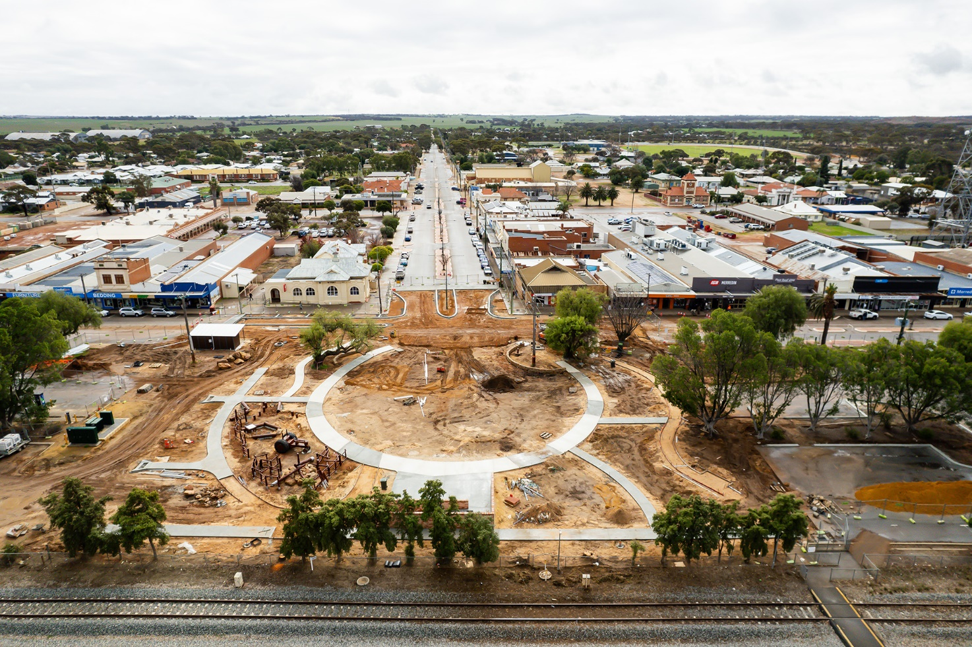

<pp>54

Board of Directors’ Governance
Our Board of Directors is responsible for the performance of WATC’s functions under the Western Australian Treasury Corporation Act 1986.

To ensure that WATC carries out its functions in the best interests of the State, our clients and other stakeholders, our Board of Directors (the Board) sets the strategic direction of WATC, with the agreement of the Treasurer, and establishes the policies and principles under which we operate.

The corporate governance processes established by the Board ensure they are able to fulfil WATC’s statutory obligations, guide the affairs of WATC and oversee our performance. The Board relies on and holds to account the Chief Executive Officer for the operational management of WATC and implementation of the strategic direction.

Board Composition
The membership of the Board is determined in accordance with Section 5B of the Western Australian Treasury Corporation Act 1986 (the Act). The directors of WATC at 30 June 2024 were as follows:

Name | Position | First Appointed | Term Expires
Michael Barnes | Chairperson | Statutory – 17/02/2014 | n/a
Michael Court | Deputy Chairperson | Statutory – 01/07/2017 | n/a
Kaylene Gulich¹ | Chief Executive Officer | Statutory – 04/02/2019 | n/a
Philippa Hobson | Director | 17/02/2020 | 31/12/2025
Susan Murphy | Director | 01/01/2019 | 31/12/2024
Wayne Zekulich | Director | 01/01/2023 | 31/12/2025

1 The Chief Executive Officer is the only director with executive responsibilities.
n/a: not applicable

<pp>55

Board Remuneration
The annual remuneration for WATC’s Board is as follows:

Name | Type of Remuneration | Period of Membership | 2023–24¹
Michael Barnes | Not eligible | 12 months | 0
Michael Court | Not eligible | 12 months | 0
Kaylene Gulich | Not eligible | 12 months | 0
Philippa Hobson | Annual | 12 months | $74,451
Susan Murphy | Annual | 12 months | $57,358
Wayne Zekulich | Annual | 12 months | $52,709
Name | Type of Remuneration | Period of Membership | 2023–24¹

1 A residual payment of $1,947 was made to David Brumby in connection with his directorship which finished on 31 December 2022.

Board Responsibilities
The Board is responsible for the performance of the functions of WATC under the Act, which include:
        - To borrow money to lend to Western Australian government authorities.
        - To develop and implement borrowing programs for the purpose of the Act.
        - To manage the financial rights and obligations of WATC and government authorities.
        - To advise on financial matters, including debt management, asset management, project and structured financing and business risks.
        - To manage investments for the Department of Treasury and other government authorities.
        - To assist government authorities with managing their financial exposures.

In fulfilling this role, the Board guides and monitors the affairs of WATC, including:
        - Reviewing and establishing, with the Treasurer’s agreement, WATC’s Strategic Development Plan and Statement of Corporate Intent each year.
        - Monitoring the performance of WATC.
        - Ensuring that appropriate accounting, risk management, budgeting, compliance, information technology and internal control policies, systems and reporting processes are in place – these include WATC’s Risk Management Policy and Business Continuity Plan.

Constitution and Proceedings of the Board
The Constitution and proceedings of the Board are provided in Schedule 2 of the Act.

Statutory Corporations (Liability of Directors) Act 1996
WATC’s directors are bound by the provisions of the Statutory Corporations (Liability of Directors) Act 1996. Accordingly, directors are required to comply with the same fiduciary responsibilities and duties of loyalty and good faith owed by directors and companies incorporated under the Corporations Act 2001. In accordance with Clause 18 of Schedule 2 of the Western Australian Treasury Corporation Act 1986, directors are required to leave the room and not take part in deliberations of matters in which they have some material personal interest.

<pp>56

Board Committees
To assist in the execution of their responsibilities, the Board has established an Audit
Committee and a People and Remuneration Committee.

Attendance at Meetings by Directors
Attendance details for each director this year are as follows:
Director | Board |  | Audit Committee |  | People and Remuneration Committee
 | Held | Attended | Held | Attended | Held | Attended
Michael Barnes | 6 | 5 | n/a | n/a | 6 | 5
Michael Court | 6 | 5 | 5 | 4 | 6 | 5
Kaylene Gulich¹ | 6 | 6 | 5 | 5 | 6 | 6
Philippa Hobson | 6 | 6 | 5 | 5 | 6 | 6
Susan Murphy | 6 | 6 | 5 | 5 | 6 | 6
Wayne Zekulich | 6 | 6 | n/a | n/a | 6 | 5
Michael Barnes | 6 | 5 | n/a | n/a | 6 | 5
1 Kaylene Gulich was invited to attend Audit Committee meetings.
n/a: not applicable

Audit Committee
The role of the Audit Committee is to give the Board additional assurance regarding the quality, integrity, reliability and adequacy of our accounting and internal control systems, financial reporting and compliance processes. At meetings of the Audit Committee, the external and internal auditors are invited to address the committee without management present.

The members of the Audit Committee at 30 June 2024 were Philippa Hobson (Chairperson), Michael Court and Susan Murphy Members are non-executive directors. The Secretary to the committee was Christabelle Madzikanda, Senior Risk Analyst.

People and Remuneration Committee
The People and Remuneration Committee reviews and makes recommendations to the Board on remuneration packages and policies applicable to the employment terms and conditions for all our people, including the Chief Executive Officer.

The members of the People and Remuneration Committee at 30 June 2024 were Michael Barnes (Chairperson), Michael Court, Kaylene Gulich, Philippa Hobson, Susan Murphy and Wayne Zekulich. The Secretary to the committee was Rebecca Ridgway, Head of Human Resources.

<pp>57

Legislation

Legislation Administered
Western Australian Treasury Corporation Act 1986
Legislation Impacting on WATC’s Activities

State Legislation
        - Auditor General Act 2006
        - Corruption, Crime and Misconduct Act 2003
        - Disability Services Act 1993
        - Electoral Act 1907
        - Electronic Transactions Act 2011
        - Equal Opportunity Act 1984
        - Fair Trading Act 2010
        - Financial Management Act 2006
        - Freedom of Information Act 1992
        - Government Trading Enterprises Act 2023
        - Long Service Leave Act 1958
        - Pay-roll Tax Assessment Act 2002
        - Procurement Act 2020
        - Public and Bank Holidays Act 1972
        - Public Interest Disclosure Act 2003
        - Public Sector Management Act 1994
        - Salaries and Allowances Act 1975
        - Stamp Act 1921
        - State Records Act 2000
        - State Superannuation Act 2000
        - Statutory Corporations (Liability of Directors) Act 1996
        - Work Health and Safety Act 2020
        - Workers’ Compensation and Injury Management Act 1981

Subsidiary Legislation
        - Financial Management Regulations 2007
        - Government Trading Enterprises Regulations 2023
        - Western Australian Treasury Corporation (Debt Paper Regulations) 1986
Commonwealth Legislation
        - A New Tax System (Goods and Services Tax) Act 1999
        - Anti-Money Laundering and Counter-Terrorism Financing Act 2006
        - Census and Statistics Act 1905
        - Copyright Act 1968
        - Disability Discrimination Act 1992
        - Fair Work Act 2009
        - Fringe Benefits Tax Act 1986
        - Income Tax Assessment Act 1936
        - Personal Property Securities Act 2009
        - Superannuation Guarantee (Administration) Act 1992
        - Taxation Administration Act 1953

<pp>58

Corporate Governance
External and internal oversight of WATC conduct and outcomes ensures adherence to
our core value of integrity.

Ethical Standards and Codes of Conduct
The Board acknowledges the need for, and the continued maintenance of, the highest standards of corporate governance practices and ethical conduct by WATC’s directors and employees. The WATC Code of Conduct (the Code) reflects and supports our values and provides our people with a clear, concise and relevant guide to behavioural standards in the workplace. The Code also applies to directors.

In developing the Code we aligned it with the principles of the Western Australian Public Sector Code of Ethics. We also endorse the code of conduct developed by the Australian Financial Markets Association.

Expectations of conduct for our directors are also outlined in the Board Charter and are in line with obligations under the Statutory Corporations (Liability of Directors) Act 1996.

Compliance
The role of our compliance function is to ensure we maintain high prudential standards and have the appropriate procedures in place to comply with the Western Australian Treasury Corporation Act 1986, and other relevant legislation, our policies and industry standards.

Auditors

External Audit
Section 21 of the Western Australian Treasury Corporation Act 1986 states:
“The provisions of the Financial Management Act 2006 and the Auditor General Act 2006 regulating
the financial administration, audit and reporting of statutory authorities apply to and in respect of the
Corporation and its operations.” In accordance with the provisions of the Financial Management Act 2006 and the Auditor General Act 2006, WATC’s external auditor is the Auditor General for Western Australia. The Auditor General engages the services of Ernst & Young to conduct the annual audit.

Internal Audit
WATC’s internal audit function is provided by PwC. Appointment to this role by WATC is subject to the Common Use Arrangements authorised by the Department of Finance for accessing audit services and financial advice.

Quarterly Report to the Treasurer
With the exception of the June quarter, WATC submits a quarterly report on our operations to the Treasurer. This report is tabled in Parliament by the Treasurer.

Professional Advice
Directors are entitled, with the prior approval of the Chief Executive Officer, to obtain such resources and information from WATC, including direct access to management and professional advisers, as they may require in order to carry out their duties as directors. Directors are also entitled, with the prior approval of the Chairperson, to seek independent professional advice, at the expense of WATC, to assist them to carry out their duties as directors.

Pricing Policy
We operate in a dynamic market where the price of our lending to the public sector is primarily driven by the cost of our borrowings. This cost fluctuates according to the prevailing level of interest rates. We set our lending rates at a competitive level aftertaking into account the cost of funds, market risk, administration costs and the return on capital. The pricing for financial advice and funds management is determined on a cost-recovery basis.

<pp>59

Insurance Policy
An insurance policy has been taken out to indemnify members of the Board against liabilities under Sections 13 and 14 of the Statutory Corporations (Liability of Directors) Act 1996. The amount of the insurance premium paid for 2023–24 was $31,290.

Expenditure on Advertising
Under Section 175ZE of the Electoral Act 1907, WATC is required to disclose any expenditure
we make to:
        - advertising agencies
        - market research organisations
        - polling organisations
        - direct mail organisations
        - media advertising organisations.
For the year ended 30 June 2024, the only disclosable expenditure incurred was in relation to advertising, where the following amounts were paid:
        - $27,975 to BondNews Ltd, trading as
        - KangaNews; and • $2,056 to Beilby Downing Teal Pty Ltd.

Unauthorised Use of Credit Cards
Our employees hold corporate credit cards where their role warrants usage. There were no instances of personal expenditure on a corporate card.

Act of Grace Payments
No act of grace payments were made during the year.

Registry and Treasury Operations
Link Market Services Ltd (trading as Link) acts as agent for providing registry services on behalf of WATC.

<pp>60 - 118

Financial Statements
Section included in this document.

<pp>119

Contact Details

Western Australian Treasury Corporation
Head Office: Level 12, St Georges Square, 225 St Georges Terrace PERTH WA 6000
Postal Address: PO Box 7282 PERTH CLOISTERS SQUARE WA 6850
Telephone: +61 8 9235 9100
Email: watc@watc.wa.gov.au
Website: watc.wa.gov.au

Registry Information
Link Market Services Limited is the agent for supplying registry services to Western Australian Treasury Corporation’s stockholders. Please call Link Market Services Limited on 1800 098 828 (FreeCall) for all stockholding enquiries.

Link Market Services Limited office addresses:

Western Australia: Level 12, QV1 Building, 250 St Georges Terrace PERTH WA 6000

Victoria: Level 13, Tower 4, 727 Collins Street MELBOURNE VIC 3008

New South Wales: Level 12, 680 George Street SYDNEY NSW 2000

Queensland: Level 21, 10 Eagle Street BRISBANE QLD 4000

